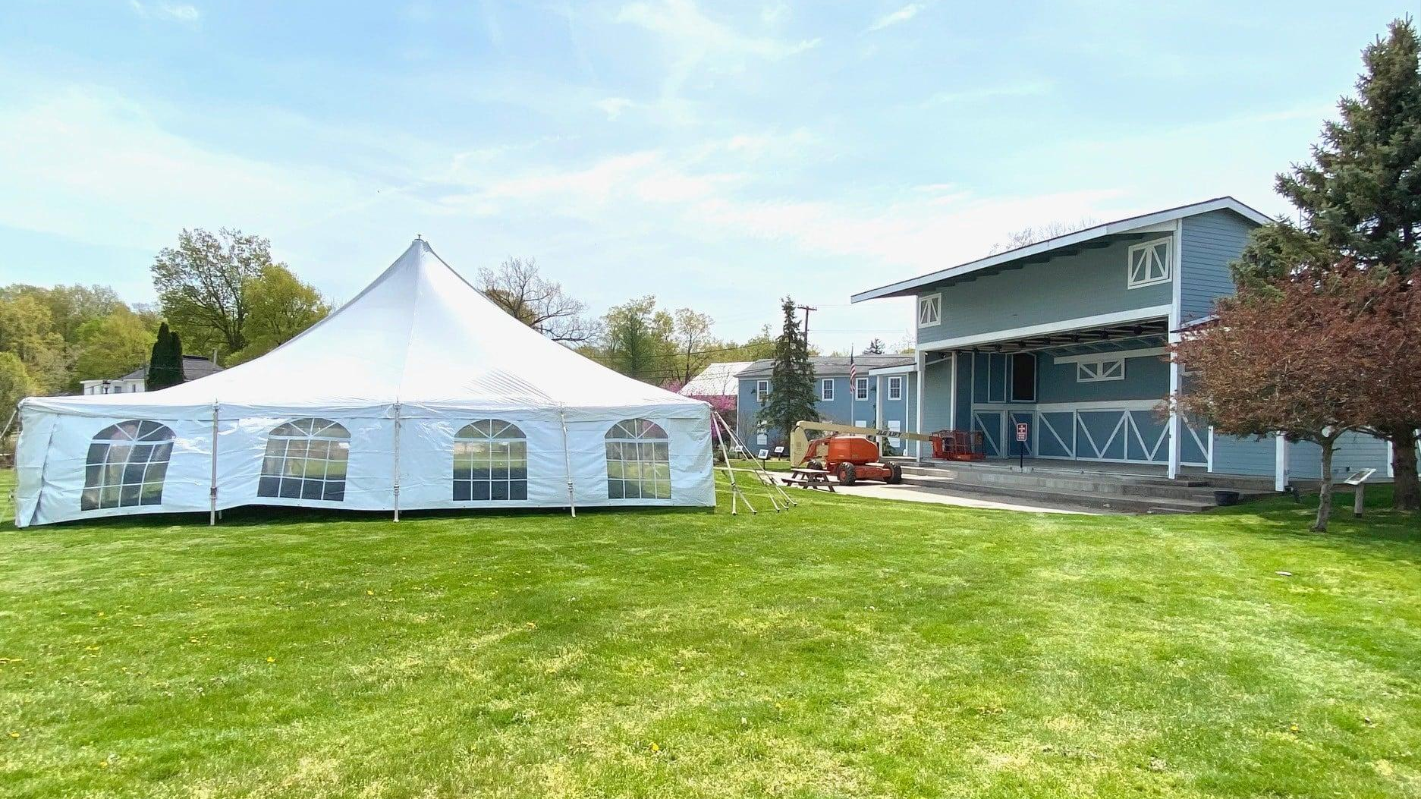

CITY OF BUCHANAN

Public Participation Plan
2023-2024
─
City of Buchanan
302 N. Redbud Trail
Buchanan, MI 49107

Table of Contents

Participation Goals and Objectives………………………………………………… 2

State Regulations on Public Participation .……………………………………… 2

Key Stakeholders .………….…….……………………………………………………… 2

Communication Toolbox .……………...….…..……………………….……..………… 4

Strategies for Outreach …..………...………………………………….……..………… 5

Communicating Results …...….……………………………………….……..………… 6

Evaluating the Effectiveness of Participation Efforts …...….…………..…… 6

Participation Goals and Objectives
- Solicit public participation in each phase of the master planning process.
- Seek involvement from a diverse range of community representatives.
- Utilize effective and equitable avenues for distributing information and receiving comments.
- Develop staff expertise in all aspects of participation.
- Support and encourage continuous improvement in the methods used to meet the public need for information and involvement.
- Record results of public engagements and recount these results back to the public.

State Regulations
Along with the desire to include a diversified public in its planning process, the municipality relies on state statutes to help guide its participation activities.
  - Michigan Open Meetings Act
  - Michigan Planning Enabling Act

Key Stakeholders

Community Partners
Regional Stakeholders
Local Chambers of Commerce
Buchanan Area Chamber of Commerce
Greater Niles Chamber of Commerce
Harbor Country Chamber of Commerce
Southwestern Michigan Regional Chamber of Commerce
Tourist Centers
Southwest Michigan Tourism Industry
West Michigan Tourist Association
Regional Employment and Housing Agencies
Neighboring Municipalities
Media Outlets
WBEZ
Niles Daily Star
Buchanan Chronicle
WNDU
Chicago Tribune
South Bend GTV
Herald Palladium
WSBT
News57
WSJM
Local Stakeholders
Local Businesses/Organizations
Community Leaders
Schools
Buchanan Development Organization
Local Brokers/Real Estate Professional
Neighborhood Groups
Public Employees
Religious Groups
Senior Groups
Social Organizations
Students
Potential Investors
Young Professionals

Communication Tool Box

Public Meetings
  - Website Posting
  - Flier Posting at City Hall
  - Newspaper Articles
  - Facebook Announcement for Special Meetings
  - Announcement at Council Meetings
  - Channel 17 Broadcasting

Proactive Practices
  - Surveys
    - Survey for Master Plan - 2021
    - Riverfront Upgrades Survey - 2023
  - Community Workshops
    - Vision for Buchanan Workshops - 2021
    - Downtown Reconstruction Workshop - 2022
  - Charrettes
    - Design Feedback on Downtown Reconstruction - 2022-2023
  - Walkabouts
    - Design Feedback on Downtown Reconstruction - 2022-2023
  - Focus Groups
    - Buchanan St. Joseph River Master Plan Steering Committee
    - Thrill on the Hill Committee
    - Victory Park Neighborhood Committee
  - Standing Committees
    - Board of Review
    - Brownfield Redevelopment Authority
    - Buchanan Area Fine Arts Council
    - Buchanan Farmers’ Market Board
    - Buchanan Tree Friends
    - Common Committee
    - Construction Board of Appeals
    - Design Review Committee
    - District Library Board
    - Friends of McCoy Creek Trail
    - Friends of Oakridge Cemetery
    - Joint Water-Sewer Board
    - OneBuchanan
    - Planning Commission
    - Watershed Quality Support Board
    - Zoning Board of Appeals
  - Social Networking

Strategies for Outreach
- Master Plan Update (2021)
- A Vision for Buchanan
- Zoning Ordinance Update (In Progress with Placemakers)
- Parks and Recreation Plan (2022-2026)
- Riverfront Improvement Master Plan
- Downtown Redevelopment
- Low Controversy Development Projects
  - Riverfront Upgrades
  - McCoy Creek Trail Extension
  - Victory Park
- High Controversy Development Projects
  - Downtown Redesign Project
  - City-Owned Properties - Development

Communicating Results
  - Public Meetings
  - Live Broadcast
  - Recording Hosted on Website and YouTube
  - Minutes Posted on Website
  - Social Media Posts When Relevant
  - Surveys
  - Social Media Posts When Relevant
  - Integrated into Planning Documents
  - Shared at Public Meetings When Relevant
  - Community Workshops/Charrettes
  - Social Media Posts When Relevant
  - Integrated into Planning Documents
  - Shared at Public Meetings When Relevant
  - Focus Groups
  - Integrated into Planning Strategy
  - Standing Committees
  - Minutes Posted on Website
  - Social Networking
  - Responsive Marketing Team
  - Daily Sharing of Relevant Information

Evaluating Success of Communication Efforts

Survey - Internal & External Evaluation Tools
- Community Development Team
  - Creates, Implements, Documents, Reports, and Analyzes Public Participation on Development Efforts
- Clerk
  - Documents Public Meeting Minutes, Posts Agendas and Minutes on Website, Posts Meeting Information on City Hall Door
- Community Development and Marketing Team
  - Manage Social Media Content
  - Meeting Broadcasting

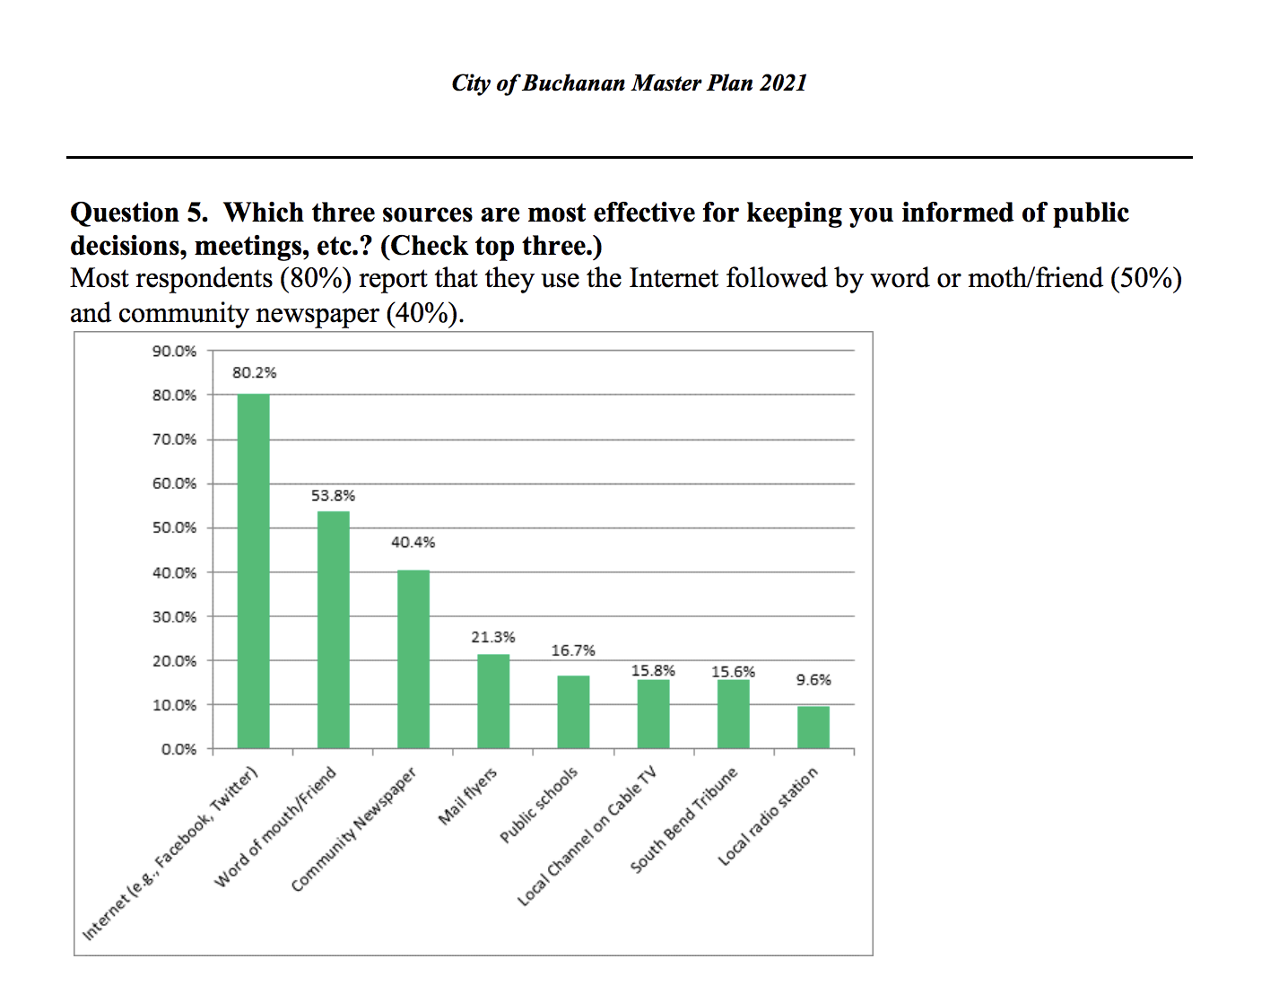
Page 87 https://www.cityofbuchanan.com/sites/default/files/fileattachments/community_development/page/4218/buchananmasterplan2021.pdf

