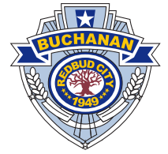
City of Buchanan
POLI POLICE DEPARTMENT

July 11, 2022

City of Buchanan Commissioners
302 N. Redbud Trail
Buchanan, MI 49107

RE: National Night Out

On Tuesday, August 2, 2022, from 6 - 9 p.m., the Buchanan Police Department will sponsor its annual National Night Out (NNO) Against Crime 2022 at McCoy Creek Park behind Buchanan High School. This event is open to all citizens in and around the Buchanan community.

NNO is designed to: (1) heighten crime and drug prevention awareness; (2) generate support for, and participation in, local anticrime efforts; (3) strengthen neighborhood spirit and police-community partnerships; and (4) send a message to criminals letting them know neighborhoods are organized and fighting back. Many neighborhoods throughout America accomplish this through such activities as block parties, parades, visits from police, flashlight walks, contests, youth activities, and anticrime rallies.

You and your families are cordially invited to attend.

Please feel free to contact myself, or Diana Selir at (269) 695-5120 if you have any questions, comments, or concerns. I look forward to your generous support on making our NNO a continued local success.

Sincerely,

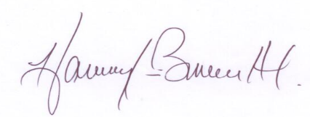

Chief Harvey Burnett, Ph.D.

Say “Yes” to Police-Community Partnerships!

