CITY OF BUCHANAN
SHORT-TERM RENTAL OVERLAY DISTRICT ORDINANCE
ORDINANCE NO. 2026.04/448

AN ORDINANCE TO PROVIDE FOR AND REGULATE SHORT-TERM RENTAL USES AND AMEND THE Unified Development Code of the City of Buchanan TO PROVIDE FOR A SHORT-TERM RENTAL OVERLAY DISTRICT AND TO PROTECT PUBLIC HEALTH, SAFETY, AND WELFARE.

IT IS HEREBY ORDAINED BY THE CITY OF BUCHANAN, BERRIEN COUNTY, MICHIGAN:

SECTION 2. AMENDMENTS
The Unified Development Code will be submitted to the Commission for review and vote on amendment with proposed new language underlined and proposed language to be deleted is stricken, as follows:
Sec. 71-5 Zoning districts established
A. Zoning under this chapter is limited to the following district designations.
8. Short-term rental Overlay District allows short-term rental uses to be located in specific geographic areas.
Sec. 71-14 Zoning districts
A. Official zoning map – Figure 71-A (Zoning Map shall have the following language added under “Zoning Districts”)
Overlay District
Short-Term Rental Overlay District – see Sec. 71-16.H.11
Sec. 71-16 General requirements
Section 71-16.H Establishment of zoning districts and regulations
1. through 10. - intentionally left blank for future use

11. Short-Term Rental Overlay District (STROD)
a. The Short-Term Rental Overlay District is established and applies to the area shown on the map under 11 b. The intent of the Short-Term Rental Overlay District and related amendments is:
i. Protect and promote the health, safety and welfare of the City’s residents, property owners, visitors, and neighborhoods by allowing short-term rentals (STR) within the City under certain conditions as found in Chapter 14 of the Code of Ordinances and in certain zoning districts;
ii. Recognizes that short-term rentals may potentially promote tourism, increase property values, and provide valuable business opportunities for property owners;
iii. Ensure that the operation of short-term rentals is done in a safe and beneficial manner for the well-being of all in the community. The character of residential zoning districts must also be protected and preserved;
iv. While short-term rentals can provide community benefits, their proliferation in residential neighborhoods can cause difficulties where character of the use takes on a more transitory and commercial character;
v. By creating the overlay district it will decrease potential conflicts with adjacent properties, limit impact on long-term housing availability and maintain the residential character of neighborhoods;
vi. The City Commission adopted Ordinance 2025.09.443 establishing regulations that must be met for short-term rental in Chapter 14 of the Code of Ordinance, which may be amended from time to time; and

b. Short-term rental Areas. The Short-Term Rental Overlay Map as established in Chapter 14 of the Code of Ordinances.

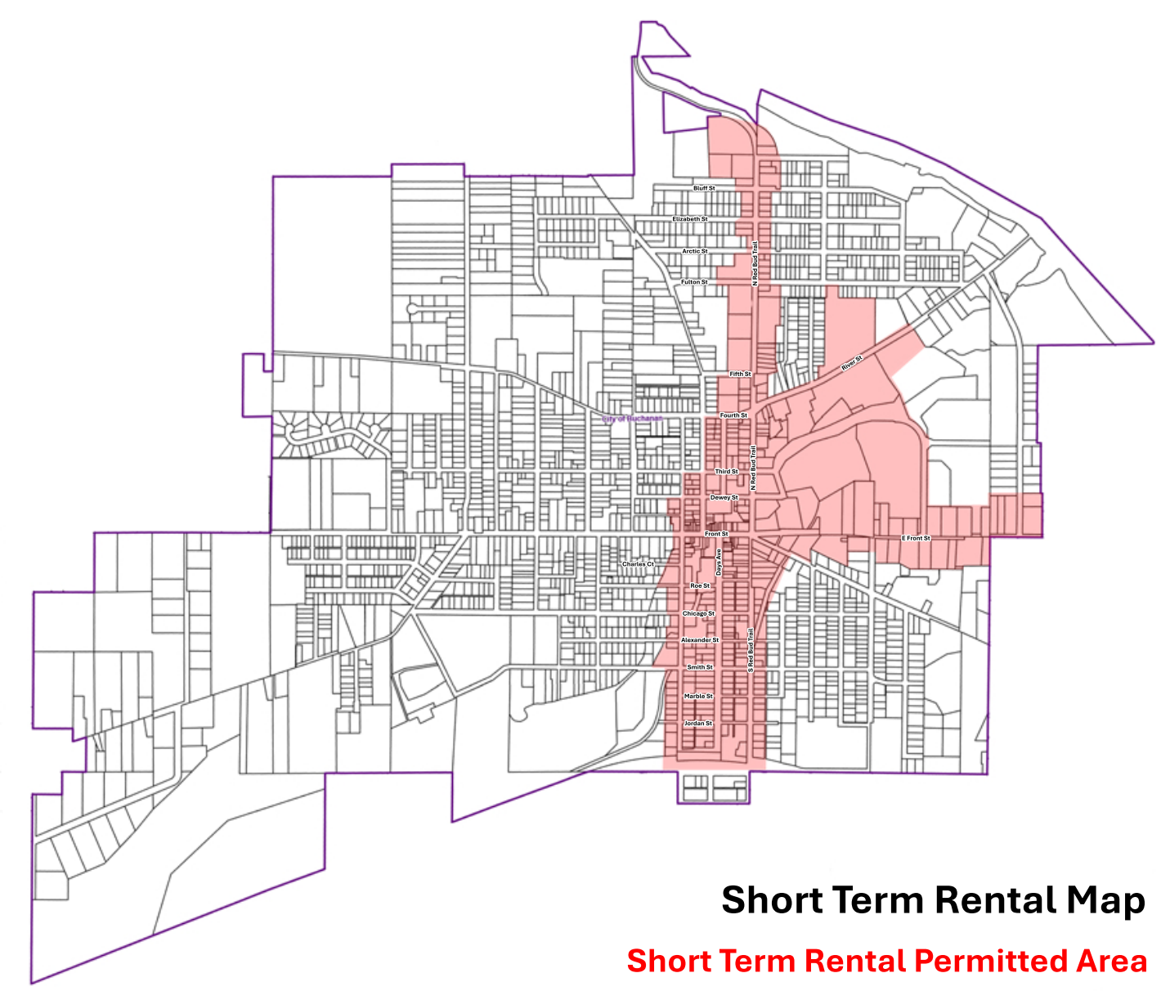

c. Applicability, Exception
i. Properties located outside of the overlay district are prohibited from requesting use variances from the Zoning Board of Appeals for the establishment of a short-term rental unit.

Section 71-18 Use
Table 71-J Use Matrix
TABLE 71-J USE MATRIX
 | N | NE | GN | NC | D | SC | I
Lodging/Accommodations
6 rooms or less |  |  | S |  |  | S
12 rooms or less Hotel/Motel |  |  |  |  |  | 
More than 12 rooms |  |  |  |  |  | 
Bed and Breakfast |  |  | S |  |  | S
Short-Term Rental |  |  | OD | OD | OD | OD | OD
Key : Permitted use 
Temporary use T
Accessory use A
Special use permit S
Prohibited use blank space
OD Overlay District

Article V. DEFINTIONS
Accessory Building: a structure which is on the same parcel of property as a principal structure and the use is incidental to the use of the principal structure. For example a residential structure may have a detached garage, storage shed, or guest house accessory dwelling unit (ADU) where allowed.
Accessory Use: a supplemental use on the same lot with, and where the use is of a nature which is customarily incidental and subordinate to, the principal use; such as a home occupation or guest house accessory dwelling unit (ADU) in a residential district.
Lodging: a land use that provides sleeping accommodations to temporary guests, whether in a whole building, a dwelling, or a portion of a dwelling, with or without meals or services. Occupancy is transient. Lodging includes hotels, inns, bed and breakfasts, tourist homes, and similar establishments. Lodging is not a residential use or a short-term rental use.
Bed and breakfast: a single-family detached residential structure operated by an owner or employee who lives on site, offering as an accessory use, overnight sleeping accommodations to transient tenants for compensation, and may provide meals.
Hotel or motel: a facility offering transient lodging accommodations to the public. Hotels may include restaurants, meeting spaces, ballrooms and banquet halls. A hotel shall not be considered or construed to be a multiple family dwelling, Bed and Breakfast or Short-Term Rental.
Overlay District: a zoning district which has definite boundaries and is superimposed over all existing zoning districts within those boundaries. The overlay district may establish additional regulations, reduce existing regulations, or extend or limit the permitted uses withing the underlying zoning district. Where there is a conflict between standards in the Overlay district and the underlying Zoning district, the standards in the Overlay district shall be applied. The intent is to address particular issues that span a geographic area and may include more than one underlying zoning district or portions of underlying zoning districts.
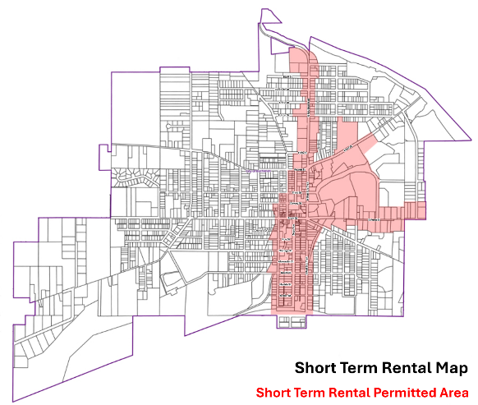
Short-Term Rental Overlay District: allows short-term rental with stays of less than one month as a permitted used in accordance with regulations found in Chapter 14 of the Code of Ordinance.

Short-Term Rental: a commercial use which is subordinate to the residential principal use of a dwelling unit, where the tenant is allowed to lease the dwelling unit for periods of less than one month. Short-term rental is a commercial use. If a tenant leases a dwelling unit for a period of at least one calendar month, this is not a short-term rental but instead is a residential use. A property authorized for short-term rental use may also be used for such residential uses. Chapter 14 of the Code of Ordinances provides requirements for operation.

Sec. 14-317 Effective Date

This Ordinance shall become effective fifteen (15) days after its adoption and publication as required by Section 7.4 of the City Charter.

MADE, PASSED, AND ADOPTED BY THE CITY COMMISSION OF THE CITY OF BUCHANAN, BERRIEN COUNTY, MICHIGAN ON THE 13th DAY OF APRIL 2026, AND IT WAS PUBLISHED IN THE BERRIEN COUNTY RECORD NEWSPAPER ON DAY 23rd OF APRIL 2026 BY

MARK WEEDON, MAYOR _______________________

KALLA LANGSTON-WEISS, CITY CLERK_____________________

CERTIFICATION, I herby certify that the above is a true and complete copy of an ordinance adopted by the City Commission of the City of Buchanan, County of Berrien, State of Michigan, at a regular meeting held on the 13TH day of April 2026, and that said meeting was conducted and public notice of said meeting was given pursuant to and in full compliance with Act No. 267, Public Acts of Michigan, 1976 as required by said act.

________________________
Kalla Langston-Weiss, City Clerk

