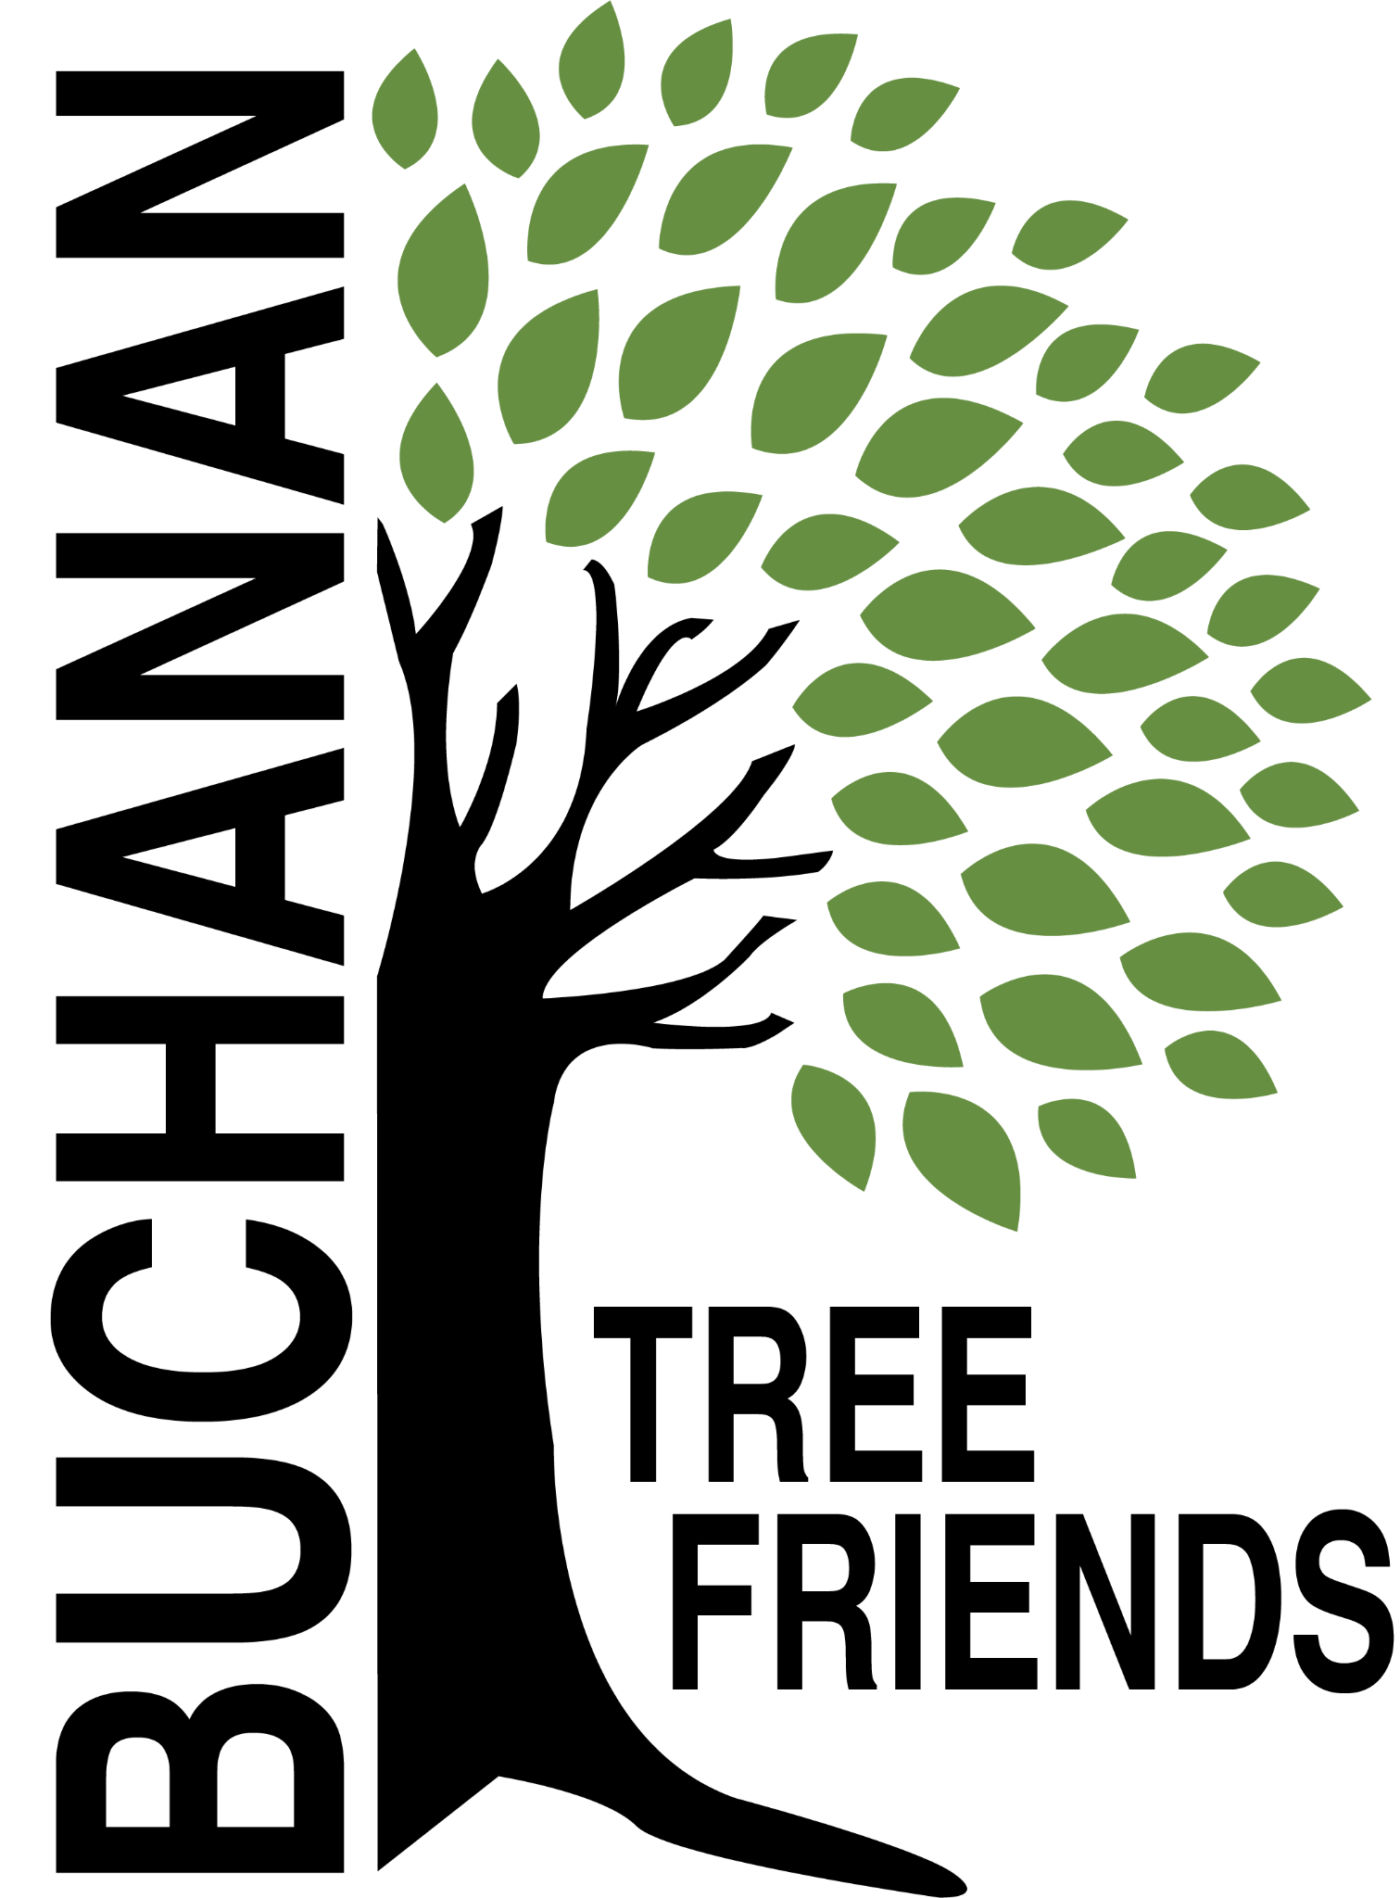

Buchanan Tree Friends - Agenda

Wednesday, June 10, 2026

6 pm, Buchanan City Hall

- Call to Order

- Attendance
Present:
Absent:
Guest:

- June Agenda Approval

- Approval of May Minutes

- Monthly Finance
- Inquire about access to account activity.

Committee Reports

- Tree Plantings & Maintenance
Chair: Richard Martin
a. Tribute Trees
- Tags
b. Fall 2026: 3rd Street
- Plan to plant on Third Street, with the majority on the north side near trail
- Kristen to report on pollution and future land development on the south side of Third Street.
c. Watering
- Update on the location of the watering tank.
- Richard and Lane have worked on the watering schedule and maps.
- Discussion on the sustainability of volunteer watering as we plant more trees.

- Governance & Financial
Chair: Brian Murphy
- Gateway agency fund idea
- City budget - request to see allocated money in the BTF line item
- Reminder: Proposed 4th Tuesday of each month, effective July 28th, 2026. The executive committee will meet the 3rd Tuesday of each month, effective July 21st 2026.
- Officers election
- Lamp posts planned for walkway by Lehman’s

- Fundraising, Marketing, and Volunteer Recruitment
Chair: Matt Pleasant
  - Future funding opportunities
  - Arbor Day celebration event review
  - Jr. Tree Friends Update (Cole)
    - Seedlings at Middle School
  - Board recruitment response (Brian)
  - Online donation options - Kristen

Old/Ongoing Business
- Idea: Education/celebration event of the City’s oldest trees in the future. Richard will use the tree inventory to identify large/old trees—ideas for a geocaching scavenger hunt. Richard and Cheri have created a preliminary list. Look at Arbor Day 2027. Have residents nominate their trees (contest).
- Richard/Lane will email by June 10 Kristen Gundersen BTF recommended tree list (separated by small, medium, large) and prohibited trees for the city as a resource (not downtown trees)
- Gundersen distributed examples:
1. A list of prohibited planting/species trees from the Michigan Department of Natural Resources.
2. A list of City of Berkley prohibited and recommended species of public trees
3. Look at Chikaming’s
New Business
- Consider planting at Smith Park (BYSBA fields)
- Will apply for an award from the Arbor Day Foundation (Brian and Elaine)

Adjournment

Next meeting is Tuesday, July 28, 2026, at 6 pm in City Hall

