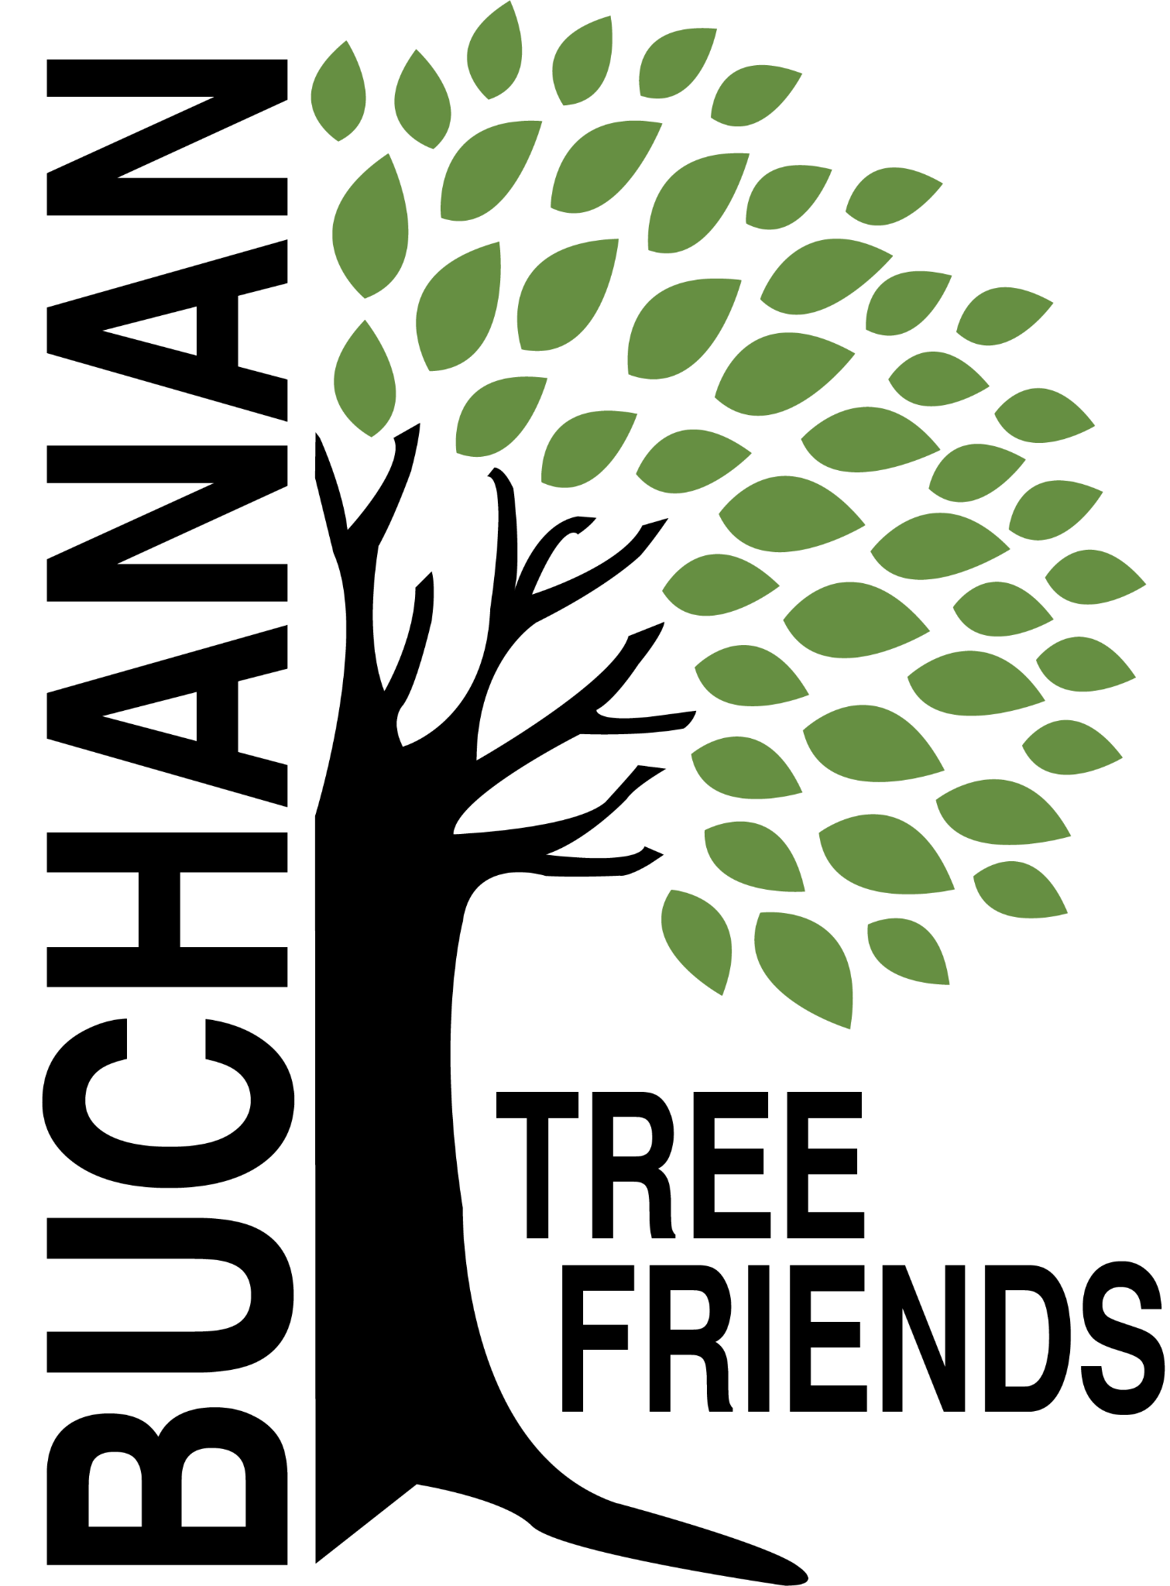

Buchanan Tree Friends - MINUTES

Wednesday, May 14, 2025

6 pm, Michigan Gateway Community Foundation

- Call to Order at 6:02 pm

- Attendance
Present: Tony McGhee, Jared Huttenstein, Elaine Rowland, Brian Murphy, Rich Martin, Cheri Martin, Lane Martin
Absent: Cala Moeller, Cole Martin, Matt Pleasant

- Agenda Approval
- Motion made by E. Rowland to move Item 7d to the top of the agenda. Supported by J. Huttenstein. All in favor. Motion carried.

- Approval of Minutes motion made by C. Martin. Supported by J. Huttenstein. All in favor. Motion carried.

- Monthly Finance Report
- Balance is approx $7,000, but the tree order is not reflected.
- The water trailer valve was replaced by city workers. Cost (~$160) was charged as a BTF expense.

Committee Reports
New Downtown Tree Plan Update
- Recommendation: to not plant two of the same species next to each other.
- Give the City Manager eight types of trees recommended to be planted.

- Executive
Chair: Brian Murphy
- Met to create the agenda for May meeting

- Tree Plantings & Maintenance
Chair: Richard Martin.
  - RECAP: Spring Planting - Sunday, April 13
- Planted 24 trees, approximately 10 different species
- Great volunteer turnout
- 8th Graders recently helped water 41 trees (including new planting)
  - Other maintenance matters
- Purchases: 10 feet of corrugated drain pipe to protect the base of about 100 trees and some things for the watering trailer.
  - Social media posts: tree planting and grant acknowledgements - in progress
  - Future planting plan (for future funding)
- Need to look for planting location/ideas for Spring 2026 in order to concentrate on maintaining the current inventory.

- Governance & Financial
Chair: Brian Murphy.
  - DNR funding update and commitment from the city
- K. Langston: Dollars have paid for tree keeper software.
- Tree Keeper software training - Cala, Jared, Shannon and maybe Craig Miller
  - Tree plans from other cities presentation

- Fundraising and Volunteer Recruitment
Chair: Cala Moeller
  - RECAP: Arbor Day Middle School (5th grade) presentation, April 24
- Success!
  - RECAP: Buchanan Plow Day, April 26
- Brian and Karen represented BTF
- In the future, perhaps plant a tree (or 3) with a presentation
  - Jr. Tree Friends (Jared)
- Had first meeting, 8 students (grades 5 & 6) and will continue next year as an official club. Some interested in having a club at the High School as well.
  - Tree watering volunteer list
- Elaine will send list to Board. Cala and Elaine will message those interested in conjunction with Rich and Cheri’s schedule (to drive the truck).
  - Future grant opportunities - based on what items we need in the near future.

- Old Business
- Boulevard tree planting - Tony has an idea about an opt-in program.
- Cheri Martin - information sheet to be presented to residents prior to tree plantings.

- New Business
- Purchase of a new tribute tree in memory of Kevin Murphy. Motion to approve the purchase by E. Rowland and seconded by L. Martin. Discussion - a London Plane to be planted near the duck pond park or the common in fall 2025. All in favor. Motion carried.
- Jerry Flenar - high school tree planting ceremony on May 16 at 3 pm
- White pines were planted today donated by Boyd Bunting and Julie Soales
- BARB meetings have been moved to the third Wednesday of each month to not overlap with BTF.
- City has $5,000 in the budget to assist with tree removals. BTF would like DPW to utilize the current tree inventory.
- We’d like to look into AEP reimbursements we used to receive for each removal.

- Adjournment at 7:02 pm. Motion to adjourn made by R. Martin and seconded by E. Rowland. All in favor. Motion carried.

Next meeting is Wednesday, June 11, 2025, at 6 pm

