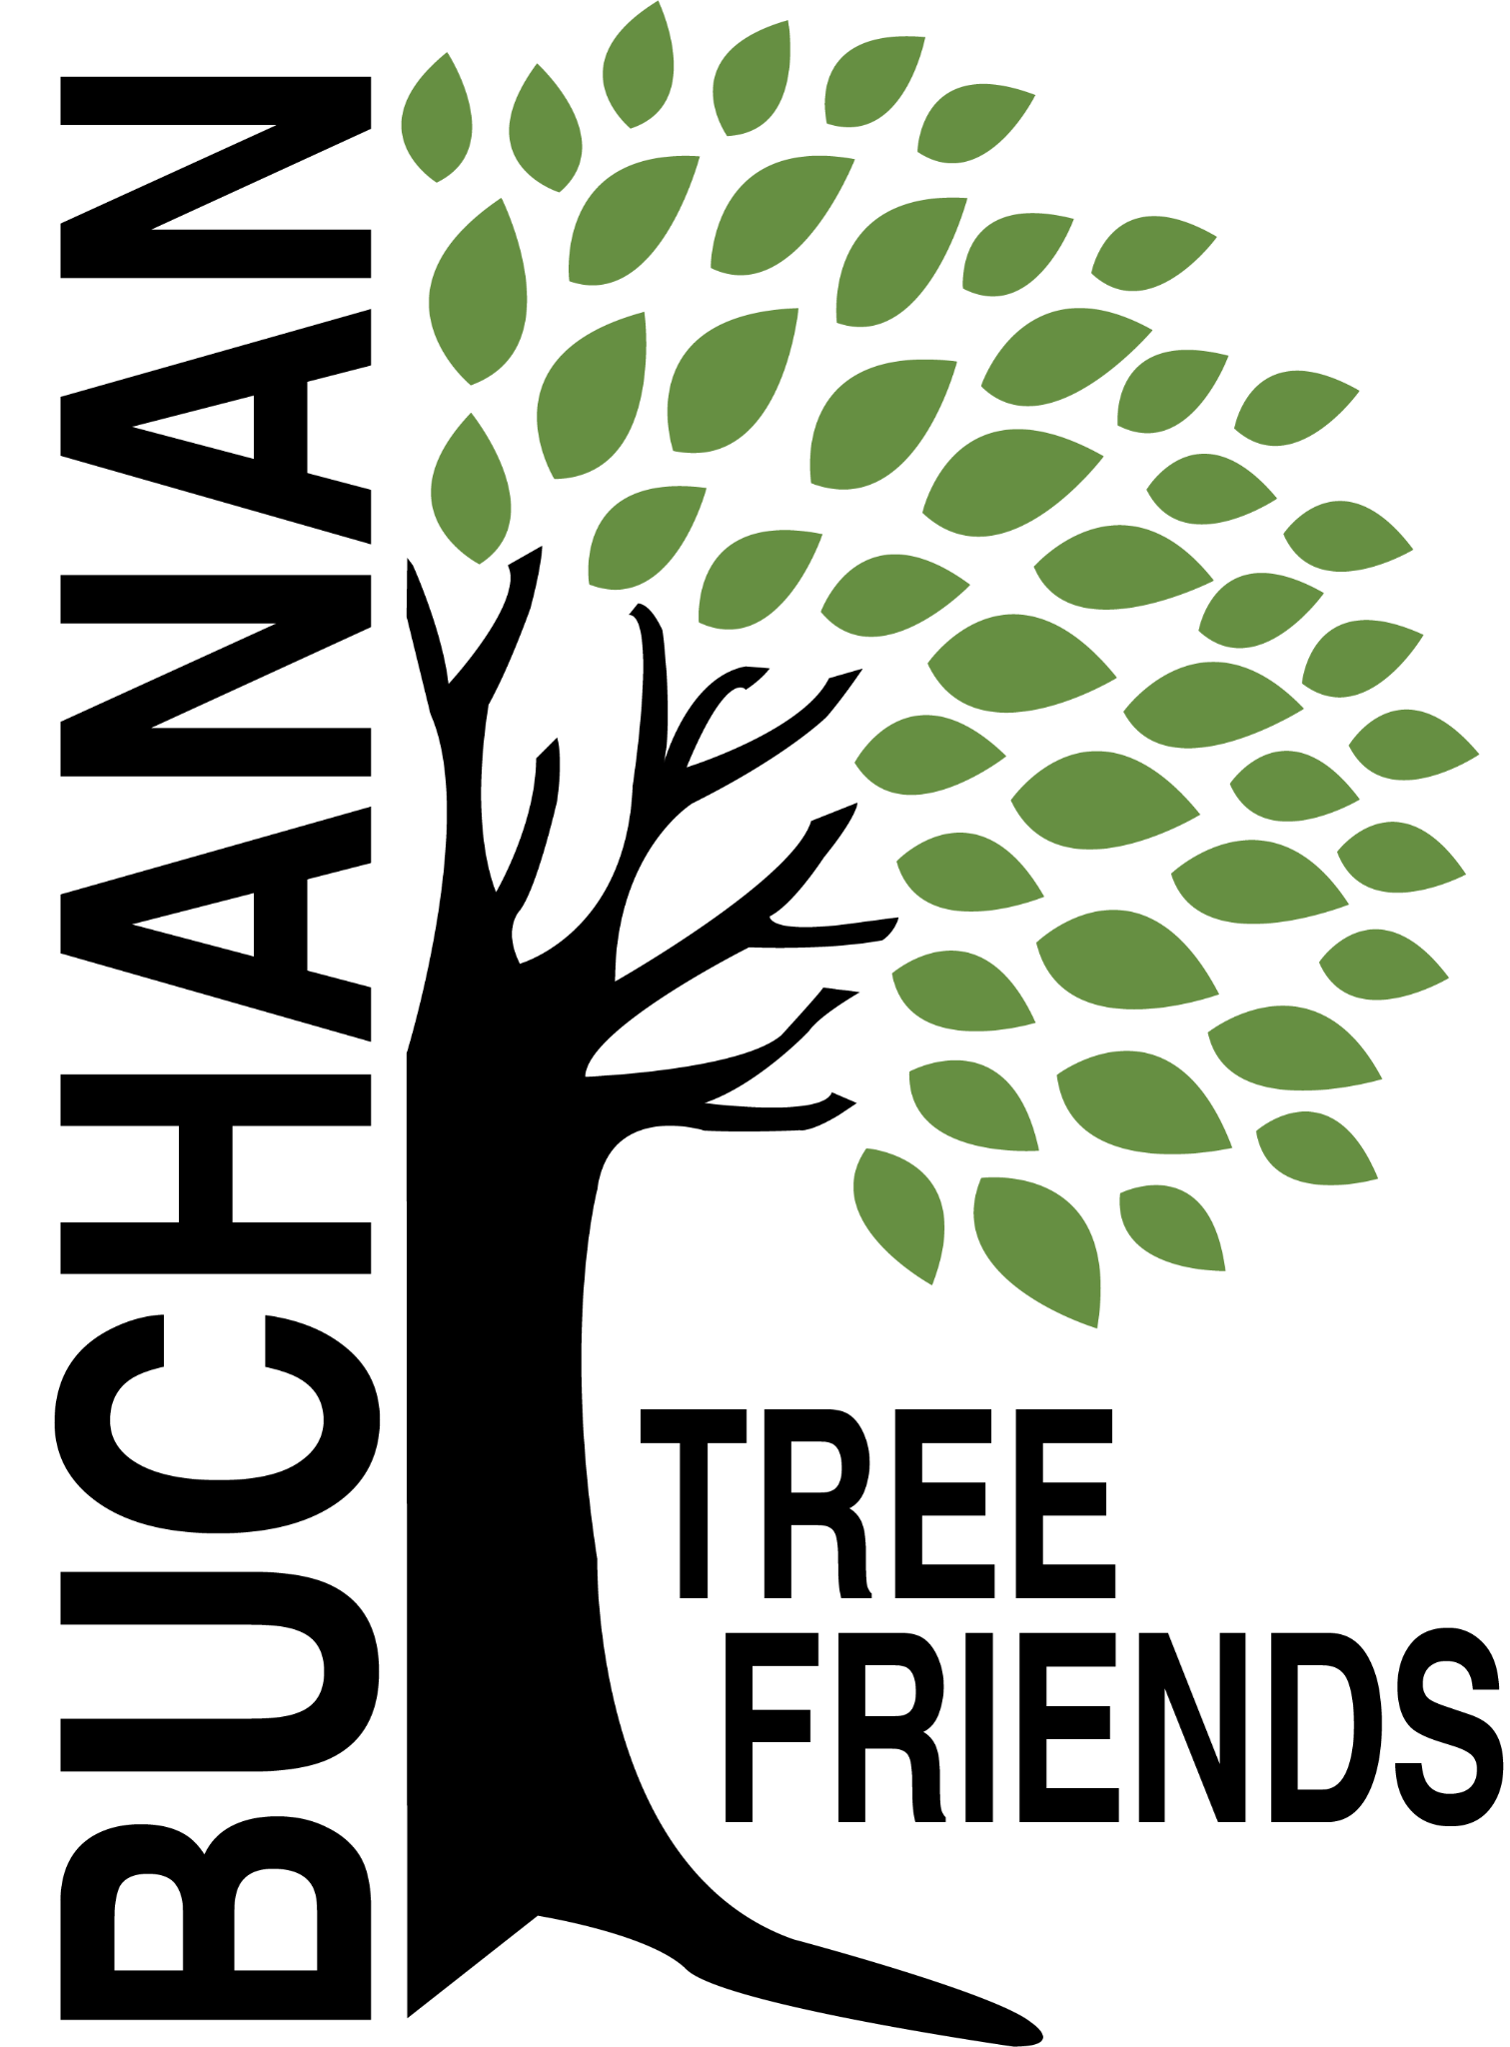

Buchanan Tree Friends - AGENDA

Wednesday, May 14, 2025

6 pm, Michigan Gateway Community Foundation

- Call to Order

- Attendance

- Agenda Approval
- Motion made by T. McGhee to move Item 7d to the top of the agenda.

- Approval of Minutes

- Monthly Finance Report

Committee Reports
- Executive
Chair: Brian Murphy
- Met to create the agenda for May meeting

- Tree Plantings & Maintenance
Chair: Richard Martin.
  - RECAP: Spring Planting - Sunday, April 13
  - Other maintenance matters
- Purchases: 100 feet of corrugated drain pipe to protect the base of about 100 trees and some things for the watering trailer.
  - Social media posts: tree planting and grant acknowledgements
  - New Downtown Tree Plan Update
  - Future planting plan (for future funding)

- Governance & Financial
Chair: Brian Murphy.
  - DNR funding update and commitment from the city
- K. Langston: dollars for the software received?
- Tree Keeper software training - Cala, Jared, Shannon and maybe Craig Miller
  - Tree plans from other cities presentation: coming soon

- Fundraising and Volunteer Recruitment
Chair: Cala Moeller
  - RECAP: Arbor Day Middle School (5th grade) presentation, April 24
  - RECAP: Buchanan Plow Day, April 26
  - Jr. Tree Friends (Jared)
  - Tree watering volunteer list
  - Future grant opportunities

- Old Business
- Boulevard tree planting - Tony has an idea about an opt-in program.
- Cheri Martin - information sheet to be presented to residents prior to tree plantings.

- New Business
- Purchase of a new tribute tree
- Jerry Flenar - high school tree planting on May 16 at 3 pm

- Adjournment

Next meeting is Wednesday, June 11, 2025, at 6 pm

