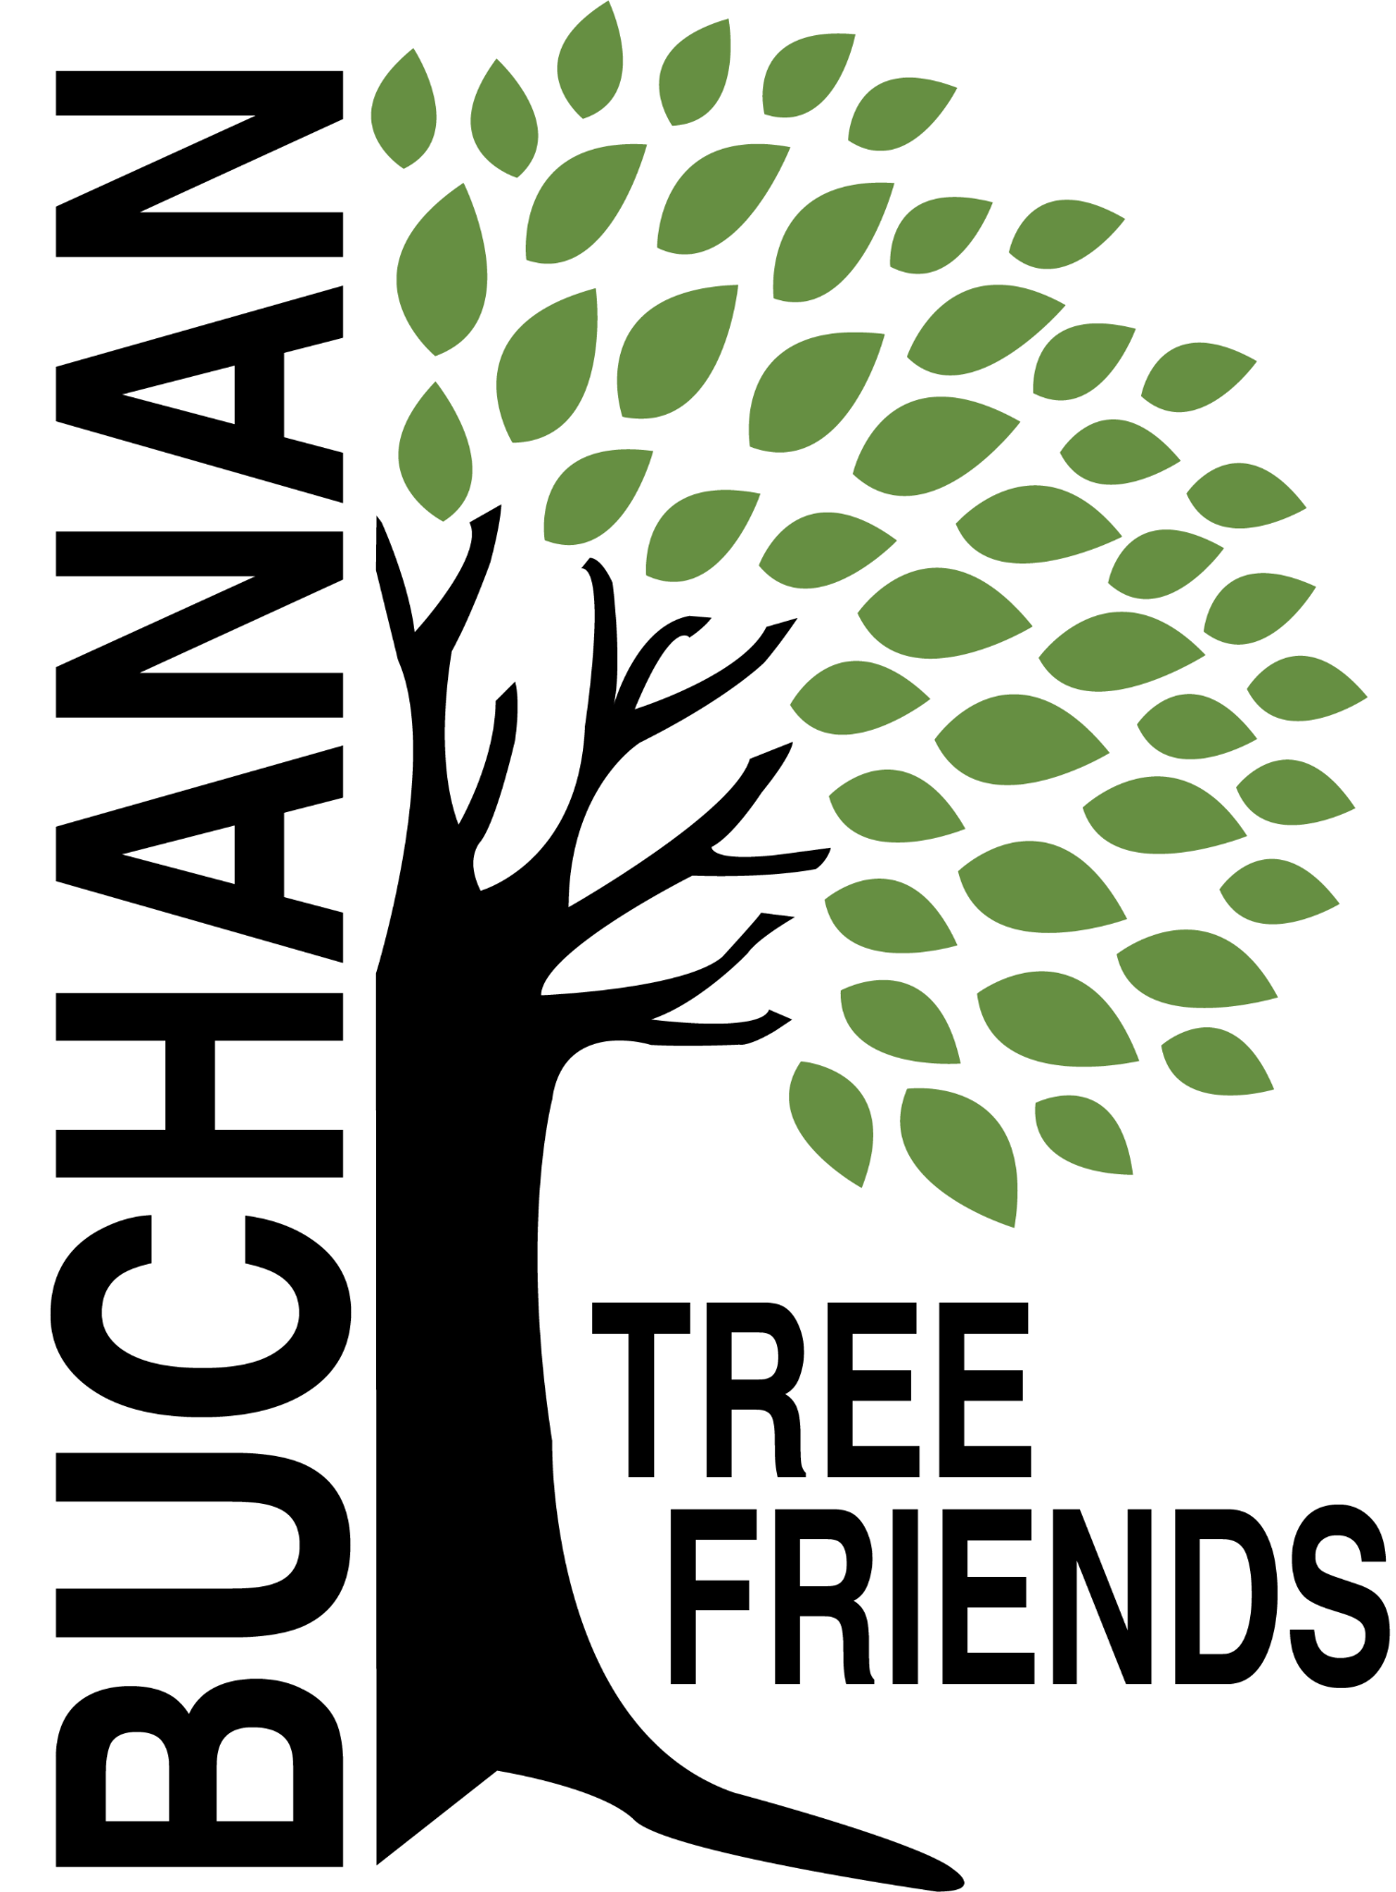

Buchanan Tree Friends - AGENDA

Wednesday, June 11, 2025

6 pm, Michigan Gateway Community Foundation

- Call to Order at

- Attendance
Present: Richard, Cheri, Lane, Brian, Elaine, Cala, Elaine
Absent: Jared, Matt, Cole

- June Agenda Approval

- Approval of May Minutes

- Monthly Finance Report
- Balance
- The water trailer valve was replaced by city workers. Cost (~$160) was charged as a BTF expense. Inquire if this was an appropriate BTF expense.

Committee Reports

- Executive
Chair: Brian Murphy
- Met to create the agenda for June meeting

- Tree Plantings & Maintenance
Chair: Richard Martin.
  - Social media posts: tree planting and grant acknowledgments - complete
  - Future planting plan (for future funding)
- DPW tree planting idea
- Need to look for planting location/ideas for Spring 2026 in order to concentrate on maintaining the current inventory.
- New tribute trees in memory of Kevin Murphy.
  - Tribute Tree Requests
- Google Sheet to place into drive

- Governance & Financial
Chair: Brian Murphy.
  - DNR funding update and commitment from the city
- Tree Keeper software training - Cala, Jared, Shannon and maybe Craig Miller
  - City has $5,000 in the budget to assist with tree removals. BTF would like DPW to utilize the current tree inventory.
  - City Tree Plan

- Fundraising and Volunteer Recruitment
Chair: Cala Moeller
  - Jr. Tree Friends (Jared).
  - Tree watering volunteer list update
  - Future grant opportunities - based on what items we need in the near future.

- Old/Ongoing Business
- Boulevard tree planting - Tony has an idea about an opt-in program.
- Cheri Martin - information sheet to be presented to residents prior to tree plantings.
- High school tree planting ceremony on May 16
- AEP reimbursements
- To purchase: 10 feet of corrugated drain pipe to protect the base of about 100 trees and some things for the watering trailer.

- New Business

- Adjournment

Next meeting is Wednesday, June 9, 2025, at 6 pm

