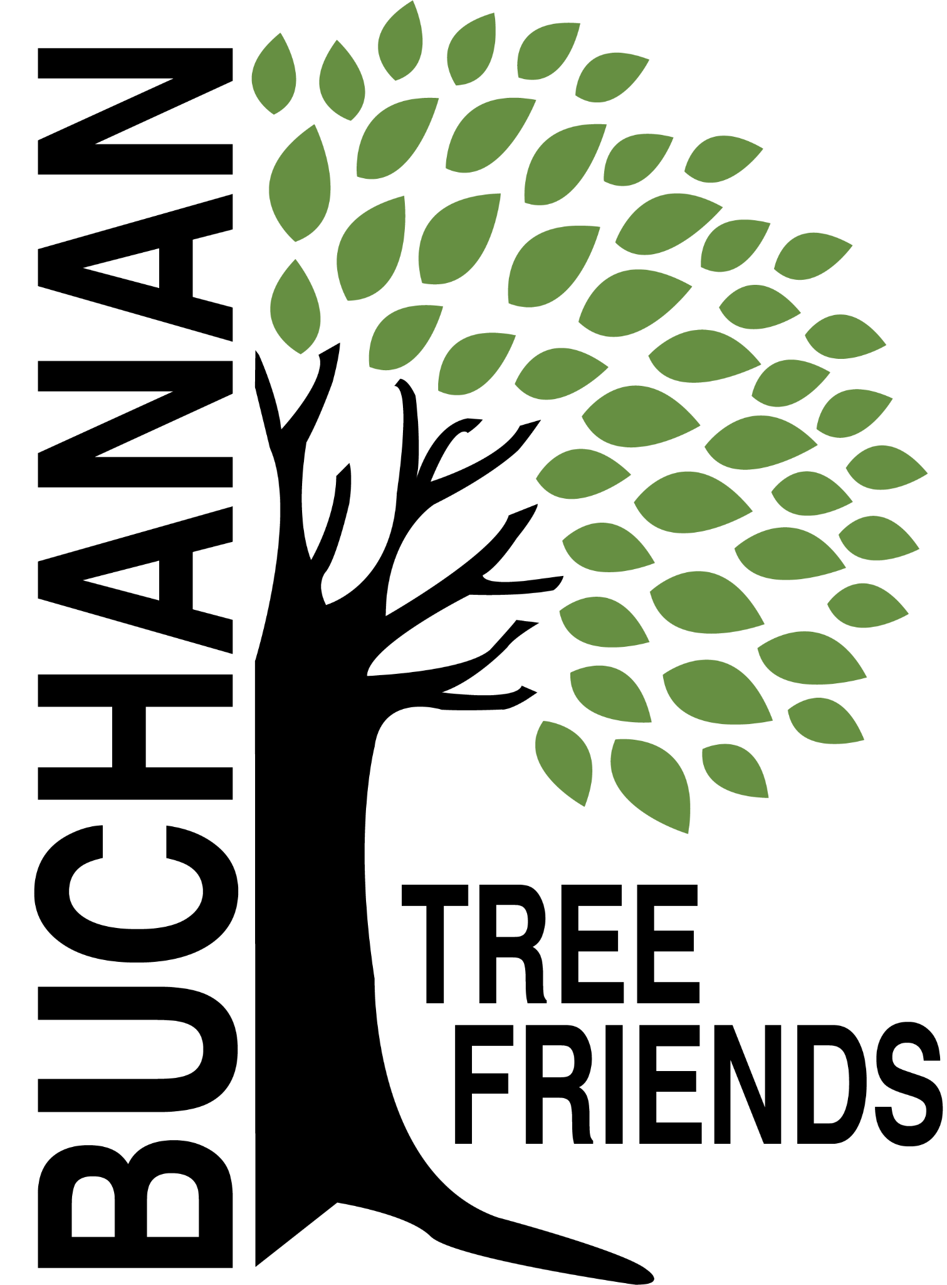

Buchanan Tree Friends - AGENDA

Wednesday, July 9, 2025

6 pm, Michigan Gateway Community Foundation

- Call to Order

- Attendance
Present:
Absent:
Guest:

- July Agenda Approval

- Approval of June Minutes

- Monthly Finance Report

Committee Reports

- Executive
Chair: Brian Murphy
- Met to create the agenda for July meeting

- Tree Plantings & Maintenance
Chair: Richard Martin.
- Water trailer

  - Future planting plan (for future funding)
- DPW tree planting idea
- Would like to work with the city to sponsor new trees near the new building. BTF would recommend and help plant them.
- Need to look for planting location/ideas for Spring 2026 in order to concentrate on maintaining the current inventory.
- Ideas: Veteran’s Memorial Park and the Duck Pond, continuation of McCoy Creek Recreation Area (in collaboration with incoming/new disc golf course), Redbud, Fourth St., Terre Coupe, Smith, Post Rd, along new McCoy Creek Trail (could collab with Fernwood, RSJ, Friends of the Trail, etc).

  - Discussion: Impact beyond Buchanan City boundaries, logistics.

  - R. Martin attended next BARB meeting to discuss Ravish Park tree locations, also inquired about budget for trees to include in park areas.

  - Tribute Tree Requests
- Google Sheet to place into drive - Elaine will create and teach R & C Martin how to use it.
- Carol Line would like two trees
- Copper Beech may be available from resident as a donation
- Joey Palucci trees near the Common
- In memory of Kevin Murphy.

- Governance & Financial
Chair: Brian Murphy.
  - DNR funding update and commitment from the city
- Tree Keeper software training - Cala, Jared, Shannon, and maybe Craig Miller
  - City has $5,000 in the budget to assist with tree removals. BTF would like DPW to utilize the current tree inventory. Murphy met with City Manager.
  - City Tree Plan

- Fundraising, Marketing, and Volunteer Recruitment
Chair: Cala Moeller
  - Jr. Tree Friends (Jared).
  - Tree watering volunteer list, include Jr. Tree Friends. (Cala and Rich)
  - Future grant opportunities - based on what items we need in the near future.
  - Tribute Tree info and marketing logistics
  - Website committee (Cole, Brian, Cala, Elaine)

- Old/Ongoing Business
- Boulevard tree planting - Tony has an idea about an opt-in program.
- Cheri Martin - information sheet to be presented to residents prior to tree plantings.
- AEP reimbursements - Brian will talk with Tony
- To purchase: 100 feet of corrugated drain pipe to protect the base of about 100 trees and some things for the watering trailer.

- New Business
- 1006 Victory St

- Adjournment

Next meeting is Wednesday, August 13, 2025, at 6 pm

