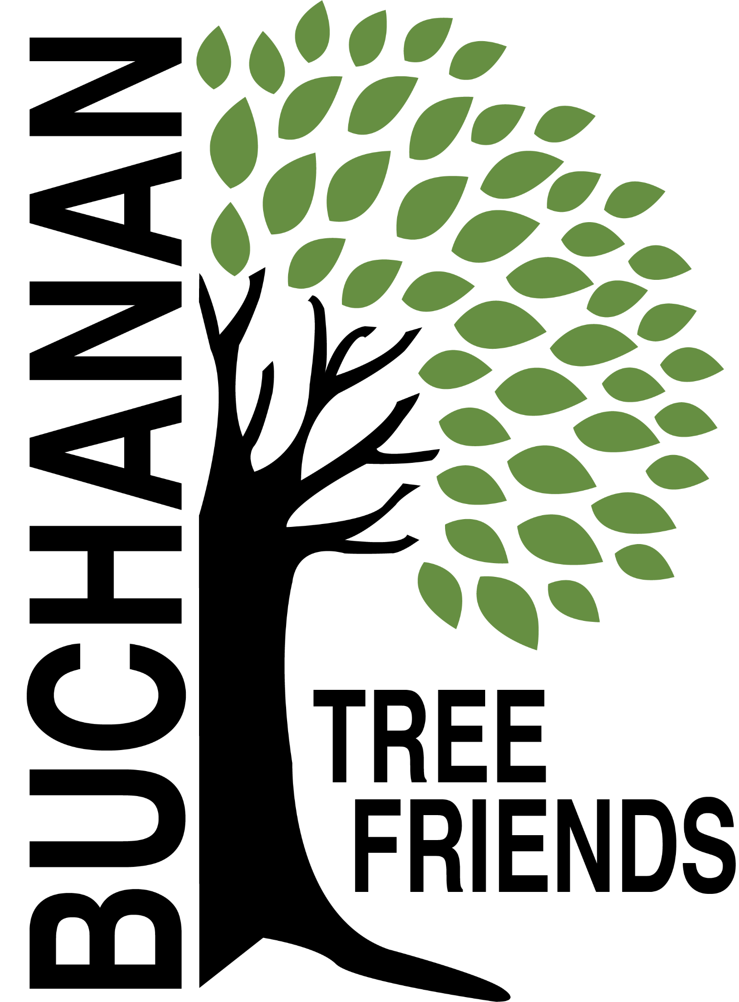

Buchanan Tree Friends - MINUTES

Wednesday, September 10, 2025

6 pm, Michigan Gateway Community Foundation

- Call to Order at 6:12

- Attendance
Present: Brian Murphy, Lane Martin, Richard Martin, Cole Martin, Cheri Martin
Absent: Elaine Rowland, Jared Huttenstine, Matt Pleasant, City representative, Cala Moeller (Resigned)
Guest: None

- September Agenda Approval - Motion to approve by Cheri Martin, second by Richard Martin

- Approval of July Minutes - Motion to approve by Richard Martin, second by Cheri Martin

- Monthly Finance Report - Current balance of $3,922. Question from Richard about the $5,000 budget allocation from the city. Should that be in our account balance?

Committee Reports
- Executive
Chair: Brian Murphy
- Met to create the agenda for September.

- Tree Plantings & Maintenance
Chair: Richard Martin.
- Watering Protocols
` It’s been difficult as the time it takes to get the trailer
Trees have been watered and most look good. Improvements to protocol still need to be made. Things such as filling the gas tank, filling the water tank, a maintenance schedule, and volunteers to lessen the work load.

b. Future planting plan (for future funding)
- Tribute Tree planting: early November 2025 (see request list)
Lane and Rich created a Google Sheet.
- Jerry Flenar - Tree in Common re: donor MGCF. Hackberry at the cemetery will be used at a cost of $200.
- Carol Line - possible 3 trees
- Copper Beech - donation (we will discuss with the homeowner to determine if transplanting the tree will be best for the tree).
- Joey Paolucci - 2 trees at the Common
- In memory of Kevin Murphy - 2 London Plane Trees. We will look for approval to plant along the new sidewalk area that will replace Dewey St. by Lehman’s. Another will be planted at Brian Murphy’s.

d. Planting location ideas for Spring 2026 to concentrate on using the inventory to identify bald spots.
- Ideas: Veteran’s Memorial Park and the Duck Pond (approximately 21 tree locations identified), continuation of McCoy Creek Recreation Area (in collaboration with incoming/new disc golf course), Redbud, Fourth St., Terre Coupe, Smith, Post Rd, along new McCoy Creek Trail (could collab with Fernwood, RSJ, Friends of the Trail, etc).
- Location should be locked in by December
- Funding ideas - Berrien Community Foundation, Gateway Foundation, current funds, or $5,000 budget.

e. Consider fall maintenance day for November. The October 9th library presentation by ReLeaf will inform what should be done.

f.. Create a public planting incentive program in conjunction with the City. Board members will think about the logistics of this.

g. Discussion: Impact beyond Buchanan City boundaries, logistics.
-No new information on this topic.

h. 108 Moccasin tree issue. This massive oak tree is estimated to be 250+ years old. It was identified in the 2022 inventory as being in need of priority pruning, which was not done. It has suffered limb drop causing property damage and an outage. Brian will be meeting with Brian Gerdes from AEP to discuss pruning.

i. Cemetery sexton to attend future Tree Friends meetings. The board is looking for city input about this idea.

- Governance & Financial
Chair: Brian Murphy.
  - DNR funding update and commitment from the city
- Tree Keeper software training, must be completed by December 31, 2025. (see below) - Jared, Shannon, and maybe Craig Miller
- Amendment to grant agreement - extension granted

  - City Tree Plan -
    - Ongoing, create a budget for $5,000
    - Brian read the nine goals outlined in the plan. He will upload the plan to the Buchanan Tree Friends Google Drive.
    - The plan will be rolled out this fall and winter. Commissioners will review a draft and have an opportunity to provide input.
    - Citizen cost share program is included in the plan.

- Fundraising, Marketing, and Volunteer Recruitment
Chair: Cala Moeller

The following items were tabled:

  - Jr. Tree Friends (Jared)

  - Tree watering volunteer list, include Jr. Tree Friends. (Cala and Rich)
- Created. Cala will email the board to review. Ready to promote.
- Watering Volunteer Description and Protocols

  - Future grant opportunities

  - Tribute Tree info and marketing logistics - TBD

  - Website committee (Cole, Brian, Cala, Elaine).
- Elaine sent an email on August 5 to schedule, so far only Cala has responded.

Old/Ongoing Business
- AEP reimbursements - Brian will talk with Brian Gerdes about this.
- To purchase: 100 feet of corrugated drain pipe to protect the base of about 100 trees, and some things for the watering trailer.

New Business
- Buchanan Library/ReLeaf program: October 9 at 6 pm
- The subject will be "Trees and Shrubs: Basic Care and Prep for Winter" and the presentation will be fully funded by the MI DNR.
- Invited BTF to co-sponsor and Brian will speak
- Brian will talk to Elaine about promotion

Adjournment - Motion to adjourn by Cheri at 7:22, second by Lane.

Next meeting is Wednesday, October 8, 2025, at 6 pm

