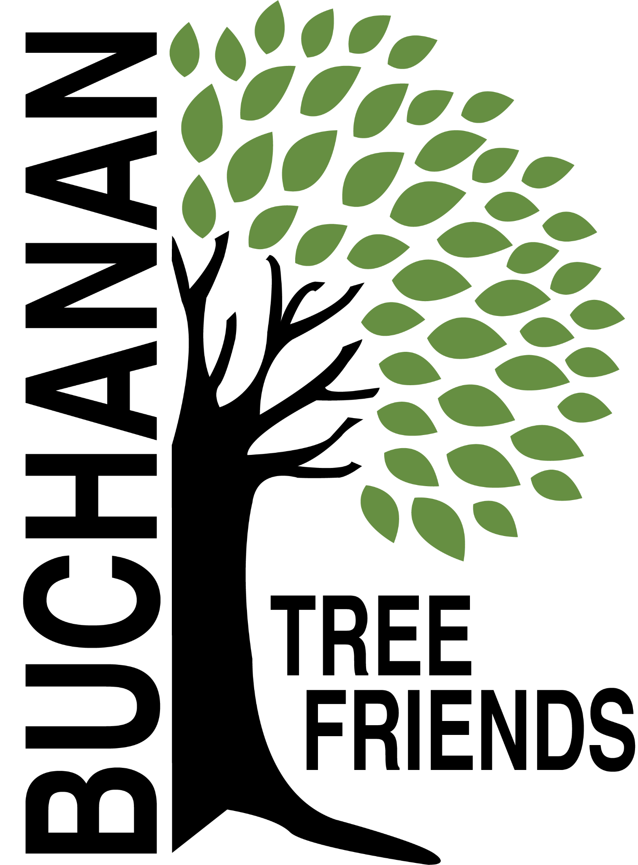

Buchanan Tree Friends - AGENDA

Wednesday, September 10, 2025

6 pm, Michigan Gateway Community Foundation

- Call to Order

- Attendance
Present:
Absent:
Guest:

- September Agenda Approval

- Approval of July Minutes

- Monthly Finance Report

Committee Reports
- Executive
Chair: Brian Murphy
- Met to create the agenda for August, decided to cancel August meeting

- Tree Plantings & Maintenance
Chair: Richard Martin.
- Watering Protocols
- Email from BTF Chair, Brian Murphy to City Manager 6.26.25
- Email from City Manager to whole BTF 7.9.25
- Email from BTF Chair, Brian Murphy to City Manager, 7.22.25
- NOTE: Every tree that has been planted since acquiring the water trailer has survived.

b. Future planting plan (for future funding)
- Tribute Tree planting: early November 2025 (see request list)

c. Requests - Lane to create a Google Sheet
- Jerry Flenar - Tree in Common re: donor MGCF
- Carol Line - two trees
- Copper Beech - donation
- Joey Palucci - the Common
- In memory of Kevin Murphy.
- Jason Stroud - 2 trees on Brookside
- Zach Haynes - 3 trees on Moccasin

d. Planting location ideas for Spring 2026 to concentrate on maintaining the current inventory.
- Ideas: Veteran’s Memorial Park and the Duck Pond (approximately 21 tree locations identified), continuation of McCoy Creek Recreation Area (in collaboration with incoming/new disc golf course), Redbud, Fourth St., Terre Coupe, Smith, Post Rd, along new McCoy Creek Trail (could collab with Fernwood, RSJ, Friends of the Trail, etc).

e. Consider fall maintenance day.

f.. Create a public planting incentive program in conjunction with the City

g. Discussion: Impact beyond Buchanan City boundaries, logistics.

h. R. Martin attended last BARB meeting to discuss Ravish Park tree locations, also inquired about the budget for trees to include in park areas.

i. 108 Moccasin tree issue

j. Use of inventory for tree removals and maintenance.

k. Cemetery sexton to attend future Tree Friends meetings

- Governance & Financial
Chair: Brian Murphy.
  - DNR funding update and commitment from the city
- Tree Keeper software training, must be completed by December 31, 2025. (see below) - Cala, Jared, Shannon, and maybe Craig Miller
- Amendment to grant agreement - extension granted

  - City Tree Plan - ongoing, create a budget for $5,000

  - Citizen cost share program

- Fundraising, Marketing, and Volunteer Recruitment
Chair: Cala Moeller
  - Jr. Tree Friends (Jared)

  - Tree watering volunteer list, include Jr. Tree Friends. (Cala and Rich)
- Created. Cala will email the board to review. Ready to promote.
- Watering Volunteer Description and Protocols

  - Future grant opportunities

  - Tribute Tree info and marketing logistics - TBD

  - Website committee (Cole, Brian, Cala, Elaine).
- Elaine sent an email on August 5 to schedule, so far only Cala has responded.

Old/Ongoing Business
- AEP reimbursements - Brian will talk with Tony and will follow up.
- To purchase: 100 feet of corrugated drain pipe to protect the base of about 100 trees, and some things for the watering trailer.
- 1006 Victory St - Resident upset about a tree BTF planted. See emails.

New Business
- Buchanan Library/ReLeaf program: October 9 at 6 pm
- The subject will be "Trees and Shrubs: Basic Care and Prep for Winter" and the presentation will be fully funded by the MI DNR.
- Invited BTF to co-sponsor and Brian will speak

Adjournment

Next meeting is Wednesday, October 8, 2025, at 6 pm

