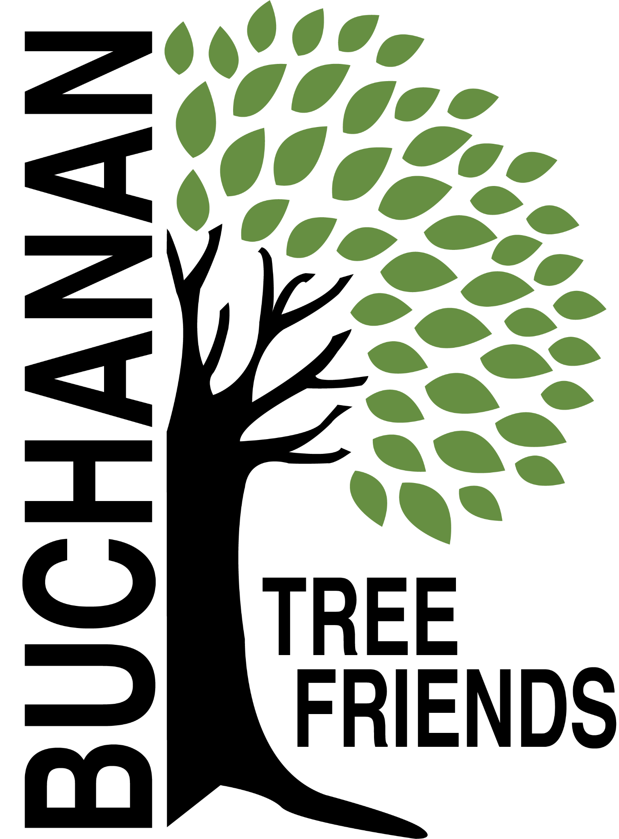

Buchanan Tree Friends - MINUTES

Wednesday, October 8, 2025

6 pm, Michigan Gateway Community Foundation

- Call to Order at 6:08 pm.

- Attendance
Present: Richard Martin, Elaine Rowland, Brian Murphy, Lane Martin, Cheri Martin, Cole Martin
Absent: Jared Huttenstine
Guest: Shannon Bryans, City of Buchanan Cemetery Sexton

- October Agenda Approval. Motion made by M. Pleasant and supported by L. Martin. All in favor. Motion carried.

- Approval of September Minutes. Motion made by L. Martin and supported by C. Martin. All in favor. Motion carried.

- Monthly Finance Report - $3,921.97 as of 8/30/2025. No report received on 10/1/2025. There has been no known activity since the last report.

Committee Reports
- Executive
Chair: Brian Murphy
- Met to create the agenda for October.
- Board development, recruitment, and succession planning
- At the end of this FY (June), Murphy will step down from the Chair position.
- Everyone must think of new board member prospects.

- Tree Plantings & Maintenance
Chair: Richard Martin.
- Watering Protocols
- Procedures needed. Will table until November. Idea: Jr. Tree Friends.
- filling the gas tank,
- filling the water tank,
- a maintenance schedule,
- volunteers to lessen the workload.

b. Future planting plan (for future funding)
- Tribute Tree planting: early November 2025 (see request list)
Lane and Rich created a Google Sheet.
- Planting date: November 1 at 10 am tentative
- The committee will communicate day-of plans
- Jerry Flenar - Tree in Common re: donor MGCF. Hackberry at the cemetery will be used at a cost of $200.
- Carol Line - possible 3 trees
- Joey Paolucci - 2 trees at the Common
- In memory of Kevin Murphy - 2 London Plane Trees. We will look for approval to plant along the new sidewalk area that will replace Dewey St. by Lehman’s. Another will be planted at Brian Murphy’s.
- Jason Lietztribute tree request to the City

c. Planting location ideas for Spring 2026 to concentrate on using the inventory to identify bald spots.
- Ideas: Veteran’s Memorial Park and the Duck Pond (approximately 21 tree locations identified), continuation of McCoy Creek Recreation Area (in collaboration with incoming/new disc golf course), Redbud, Fourth St., Terre Coupe, Smith, Post Rd, along new McCoy Creek Trail (could collab with Fernwood, RSJ, Friends of the Trail, etc).
- Location should be locked in by December with approval from BARB
- Funding ideas - Berrien Community Foundation, Gateway Foundation, current funds, or $5,000 budget.

d. Decide on a fall maintenance day for November. The October 9 library presentation by ReLeaf will inform what should be done

e. 108 Moccasin and 101 3rd Street trees
- The Majestic Moccasin tree caused a large power outage recently. T. McGhee introduced B. Murphy and R. Martin to Brian (an arborist) from AEP. Tree will be trimmed and saved = success!
- The Third Street corner tree is deforming the sidewalk and is believed to be causing a sewage problem for the homeowner. City Manager has decided to remove it this fall = devastating.

f. Cemetery sexton to attend future Tree Friends meetings? The board is looking for city input about this idea.
- We are excited he is attending the meeting this evening.

- Governance & Financial
Chair: Brian Murphy
  - City Tree Plan Draft - editing and incorporating thoughts from Davey and Board. Would like to present the draft to City Commissioners with Lee Mueller for comment, then the final plan will be given to the City to accept (no approval needed).

- Fundraising, Marketing, and Volunteer Recruitment
- New Committee Chair: Matt Pleasant
  - Jr. Tree Friends (Jared)

  - Tree watering volunteer list, including Jr. Tree Friends.
- Created. Cala emailed the board to review. Ready to promote.
- Watering Volunteer Description and Protocols

  - Future grant opportunities

  - Tribute Tree info and marketing logistics

  - Website committee (Cole, Brian) - Cole and Brian will meet sometime during the week of 10/13/2025 to start talking about a website.

Old/Ongoing Business
- AEP reimbursements - Brian will continue to discuss this with Brian Gerdes. Cole has also agreed to talk to Brian Gerdes.
- To purchase: 100 feet of corrugated drain pipe to protect the base of about 100 trees, and some things for the watering trailer.
- Buchanan Library/ReLeaf program: October 9 at 6 pm
- The subject will be "Trees and Shrubs: Basic Care and Prep for Winter," and the presentation will be fully funded by the MI DNR.
- Invited BTF to co-sponsor, and Brian will speak
- A volunteer/board member interest sheet will be available at the event.

New Business
- Tree Tags, M. Pleasant will inquire about a new printer in Buchanan. We need tags for 2024 and 2025 Tribute Trees.
- Education/celebration event of the City’s oldest trees in the springtime.
- Need bylaw review: B. Murphy will amend

Adjournment at 6:58 pm, motion made by R. Martin supported by M. Pleasant. All in favor. Motion carried.

Next meeting is Wednesday, November 12, 2025, at 6 pm

