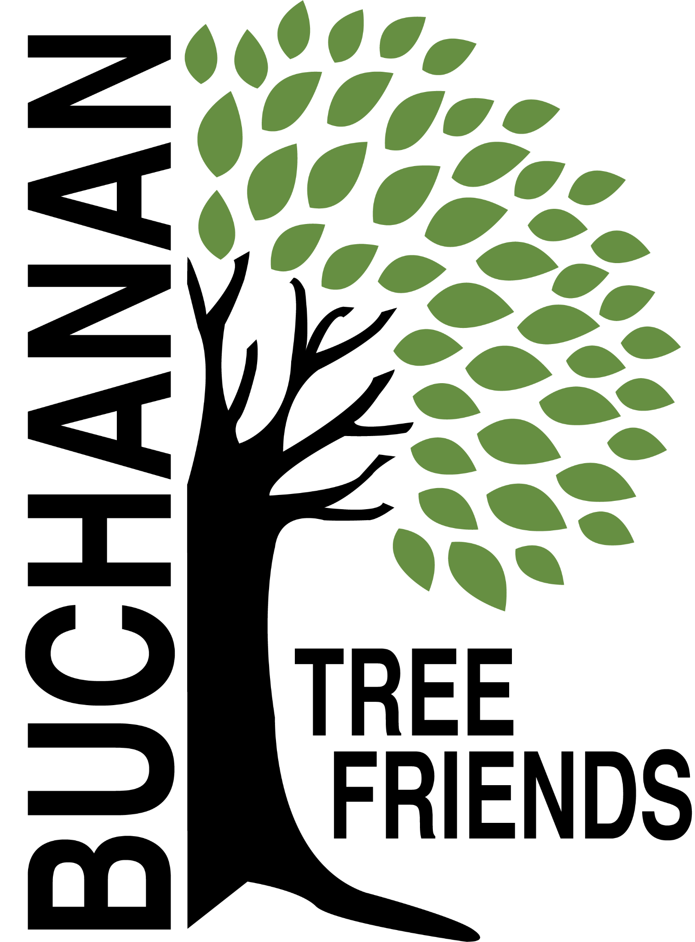

Buchanan Tree Friends - AGENDA

Wednesday, October 8, 2025

6 pm, Michigan Gateway Community Foundation

- Call to Order

- Attendance
Present:
Absent:
Guest:

- October Agenda Approval

- Approval of September Minutes

- Monthly Finance Report -

Committee Reports
- Executive
Chair: Brian Murphy
- Met to create the agenda for October.
- Board development, recruitment, and succession planning

- Tree Plantings & Maintenance
Chair: Richard Martin.
- Watering Protocols
- filling the gas tank,
- filling the water tank,
- a maintenance schedule,
- volunteers to lessen the workload.

b. Future planting plan (for future funding)
- Tribute Tree planting: early November 2025 (see request list)
Lane and Rich created a Google Sheet.
- Need to set planting date.
- Jerry Flenar - Tree in Common re: donor MGCF. Hackberry at the cemetery will be used at a cost of $200.
- Carol Line - possible 3 trees
- Joey Paolucci - 2 trees at the Common
- In memory of Kevin Murphy - 2 London Plane Trees. We will look for approval to plant along the new sidewalk area that will replace Dewey St. by Lehman’s. Another will be planted at Brian Murphy’s.
- Jason Lietztribute tree request to the City

c. Planting location ideas for Spring 2026 to concentrate on using the inventory to identify bald spots.
- Ideas: Veteran’s Memorial Park and the Duck Pond (approximately 21 tree locations identified), continuation of McCoy Creek Recreation Area (in collaboration with incoming/new disc golf course), Redbud, Fourth St., Terre Coupe, Smith, Post Rd, along new McCoy Creek Trail (could collab with Fernwood, RSJ, Friends of the Trail, etc).
- Location should be locked in by December with approval from BARB
- Funding ideas - Berrien Community Foundation, Gateway Foundation, current funds, or $5,000 budget.

d. Decide on a fall maintenance day for November. The October 9 library presentation by ReLeaf will inform what should be done

e. 108 Moccasin and 101 3rd Street trees

f. Cemetery sexton to attend future Tree Friends meetings? The board is looking for city input about this idea.

- Governance & Financial
Chair: Brian Murphy
  - City Tree Plan Draft

- Fundraising, Marketing, and Volunteer Recruitment
- Need to find a new Committee Chair
  - Jr. Tree Friends (Jared)

  - Tree watering volunteer list, including Jr. Tree Friends.
- Created. Cala will email the board to review. Ready to promote.
- Watering Volunteer Description and Protocols

  - Future grant opportunities

  - Tribute Tree info and marketing logistics

  - Website committee (Cole, Brian)

Old/Ongoing Business
- AEP reimbursements - Brian will continue to discuss this with Brian Gerdes.
- To purchase: 100 feet of corrugated drain pipe to protect the base of about 100 trees, and some things for the watering trailer.
- Buchanan Library/ReLeaf program: October 9 at 6 pm
- The subject will be "Trees and Shrubs: Basic Care and Prep for Winter," and the presentation will be fully funded by the MI DNR.
- Invited BTF to co-sponsor, and Brian will speak
- A volunteer/board member interest sheet will be available at the event.

New Business

Adjournment

Next meeting is Wednesday, November 12, 2025, at 6 pm

