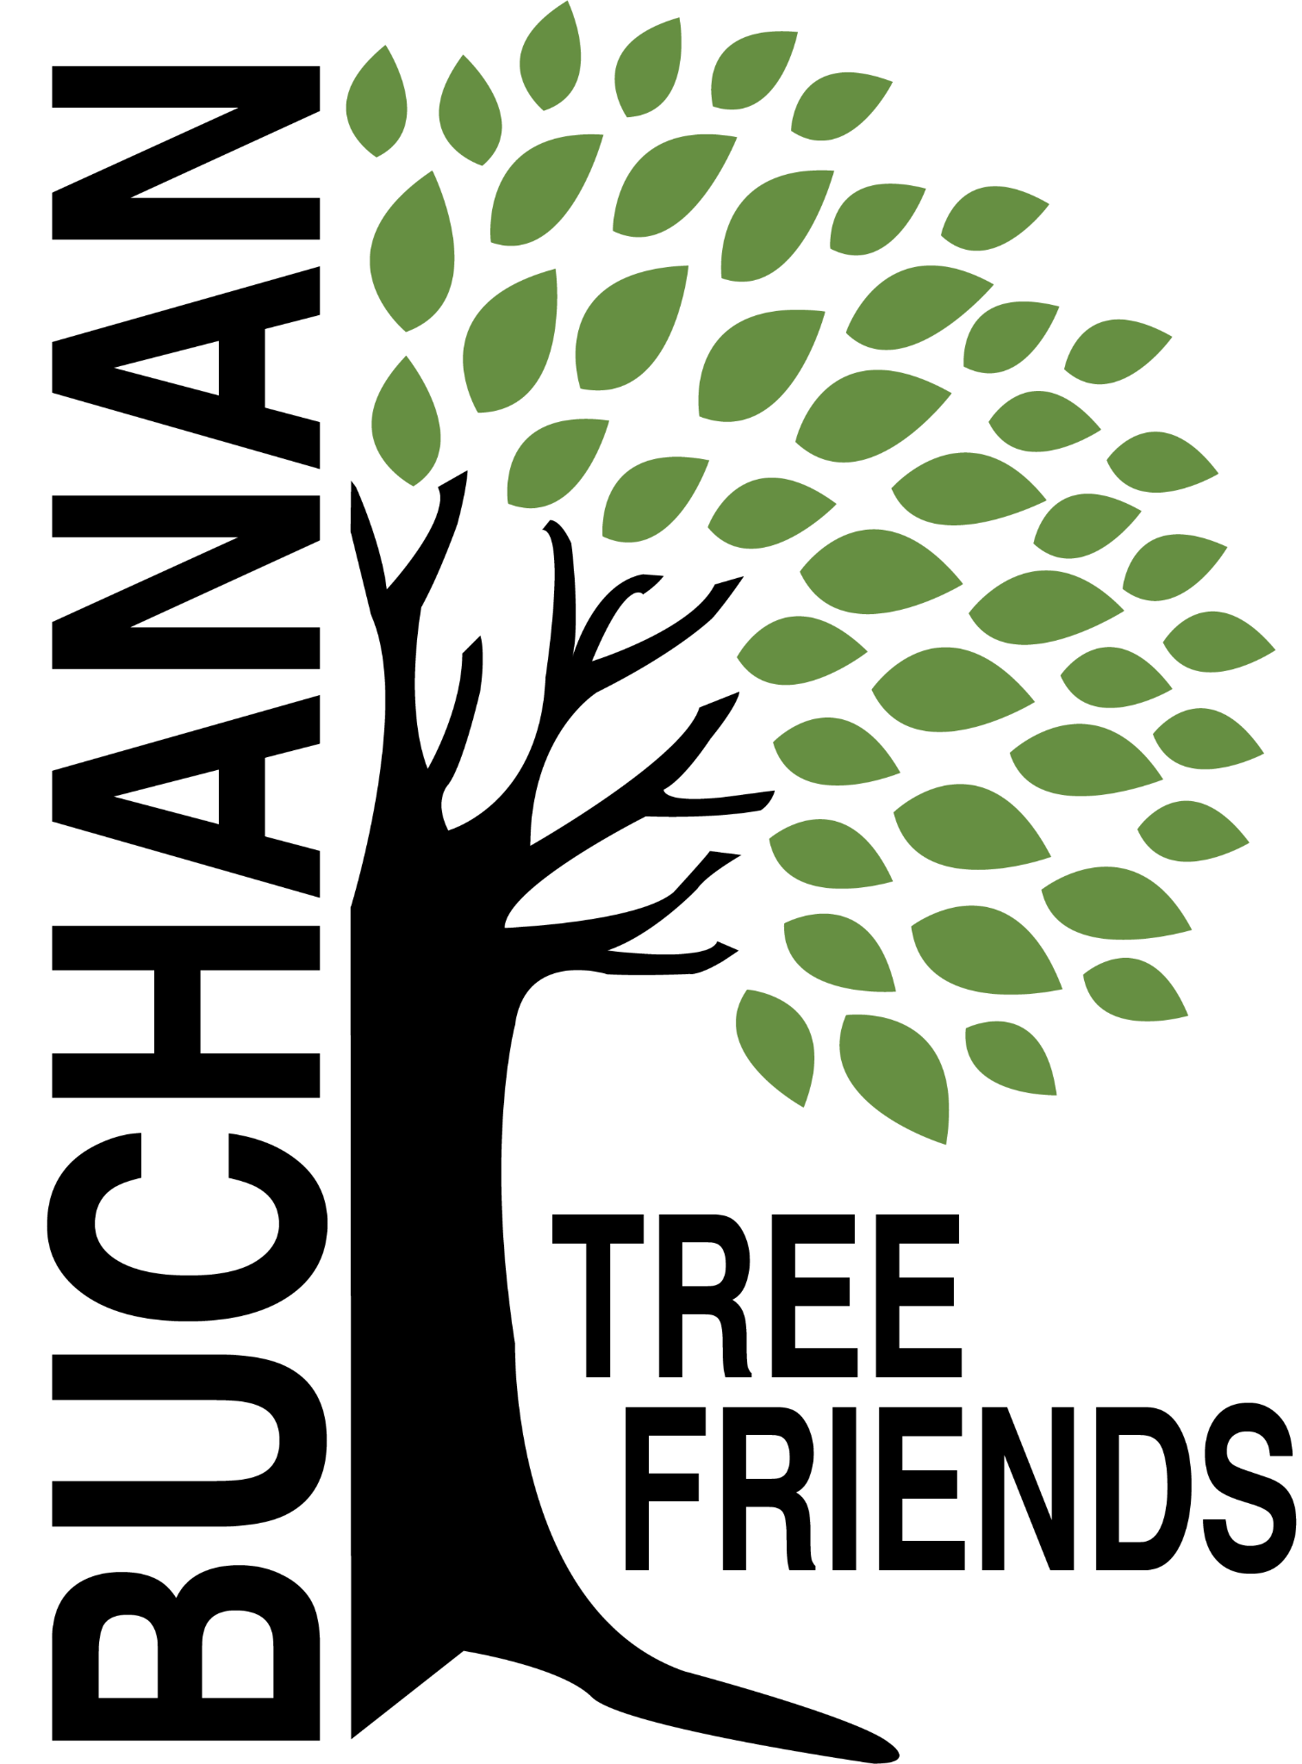

Buchanan Tree Friends - MINUTES

Wednesday, November 12, 2025

6 pm, Michigan Gateway Community Foundation

- Call to Order at 6:06 pm

- Attendance
Present: Richard Martin, Cheri Martin, Lane Martin, Elaine Rowland, Cole Martin,
Absent: Matt Pleasant, Jared Huttenstein, Brian Murphy, City Representative
Guest: Miles Martin

- November Agenda Approval motion made by L. Martin and supported by C. Martin. All in favor. Motion carried.

- Approval of October Minutes motion made by C. Martin and supported by L. Martin. All in favor. Motion carried.

- Monthly Finance Report $4,350

Committee Reports
- Executive
Chair: Brian Murphy, absent. Richard Martin reported.
- Met to create the agenda for November.
- New BTF bylaws were shared with board members. Review and send bring ideas for any changes to the December meeting. Plan to vote in January.
Discussion:
- Board development, recruitment, and succession planning
- At the end of this FY (June), Murphy will step down from the Chair position.
- Everyone must think of new board member prospects.
- Ideas to recruit new members:
- Flyer (printed & digital) with accomplishments, tasks, photos
- Think of specific holes we need to fill: manual labor, fundraising, marketing, recruitment, watering
- Like-minded people who want to join the cause
- Elaine will draft a press release
- Update and reprint brochure.

- Tree Plantings & Maintenance
Chair: Richard Martin.
- Watering Protocols
- SOP need to be written up by the committee. Group will meet on 11/25/25 at 7 pm.
- Idea: Jr. Tree Friends.
- filling the gas tank,
- filling the water tank,
- a maintenance schedule,
- volunteers to lessen the workload.

b. Tribute Tree Planting Fall of 2025
- Picking up 3 trees on Monday from Great Lakes Ornamentals in Fennville to be dug and planted next week, Tuesday, November 18 at 4:30 pm by Lehmans, Brian Murphy’s home, and the Common.
- Planted 2 in the Common and two at Carol Line’s home.

c. Planting location ideas for Spring 2026 to concentrate on using the inventory to identify bald spots.
- Ideas: Veteran’s Memorial Park and the Duck Pond (approximately 21 tree locations identified), continuation of McCoy Creek Recreation Area (in collaboration with incoming/new disc golf course), Redbud, Fourth St., Terre Coupe, Smith, Post Rd, along new McCoy Creek Trail (could collab with Fernwood, RSJ, Friends of the Trail, etc).
- Committee will discuss on November 25 at 7 pm
- Locations should be submitted to Tony McGhee ASAP
- Funding ideas - Berrien Community Foundation, Gateway Foundation, current funds, or $5,000 budget.
- Spring, 2026: Replacing a failed tree at McCarty’s. Charge them the cost of the tree.

d. Decide on a fall maintenance day for November or December
- New maintenance needs for broken limbs that were broken and need to be removed from the 11.10.25 snowstorm. 1 pm group will meet at the Common, bring loppers, rakes, and hand rakes.

f. Cemetery sexton to attend future Tree Friends meetings? The board is looking for city input about this idea.

g. Mark Leazenby donated $50, because Richard helped him plant trees on his property

- Governance & Financial
Chair: Brian Murphy, absent. Reported by Lane Martin.
  - City Tree Plan Draft emailed to board for review. Discussion. Comments needed by tomorrow, November 13.

- Fundraising, Marketing, and Volunteer Recruitment
- New Committee Chair: Matt Pleasant
  - This committee needs development and needs to be an area of focus
- Added Matt to the Executive Committee's monthly meeting

  - Tribute Tree info and marketing logistics
- would like to get approx 20 tribute trees per year

  - Future grant opportunities

  - Private donations

  - Events

  - Jr. Tree Friends (Jared)

  - Tree watering volunteer list, including Jr. Tree Friends.
- Created. Cala emailed the board to review. Ready to promote.
- Watering Volunteer Description and Protocols

Old/Ongoing Business
- AEP reimbursements - Brian will continue to discuss this with Brian Gerdes. Cole has also agreed to talk to Brian Gerdes.
- To purchase: some things for the watering trailer.
- Tree Tags, M. Pleasant inquired and will follow up about a new printer in Buchanan. We need tags for 2024 and 2025 Tribute Trees. Cheri will bring information to the next meeting. And, Matt will bring pricing. Board will vote.
- Website committee (Cole, Brian) - Cole and Brian will meet sometime during the week of October 13, 2025, to discuss a website.
- BTF webpage on the City’s website

New Business
- Education/celebration event of the City’s oldest trees in the springtime.

Adjournment at 7:06 pm motion made by E. Rowland and supported by C. Martin. All in favor. Motion carried.

Next meeting is Wednesday, December 10, 2025, at 6 pm

