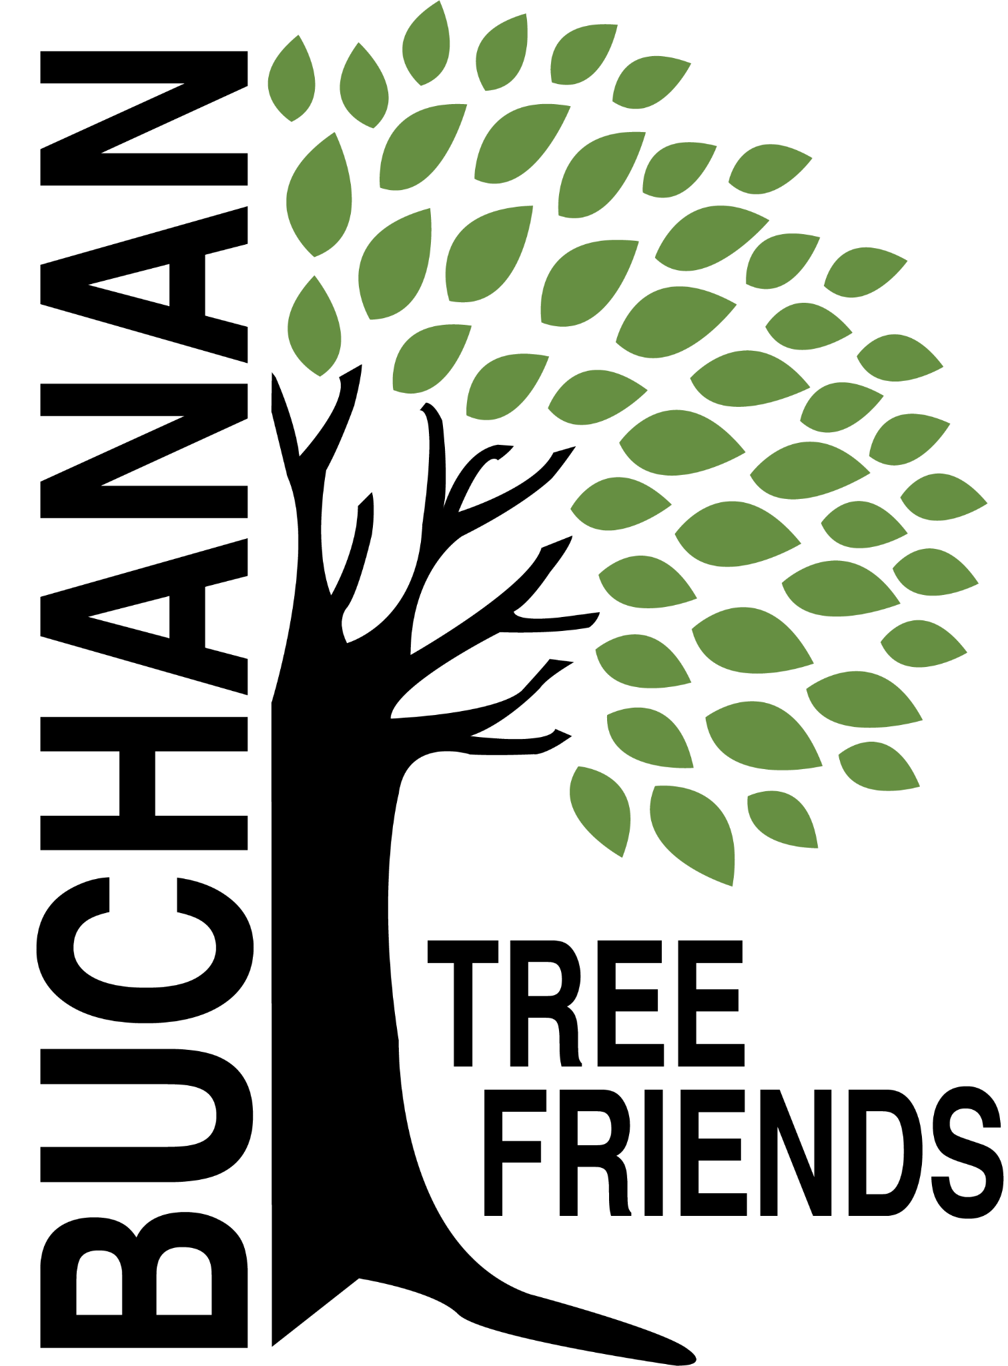

Buchanan Tree Friends - AGENDA

Wednesday, December 10, 2025

6 pm, Michigan Gateway Community Foundation

- Call to Order

- Attendance
Present:
Absent:
Guest:

- December Agenda Approval

- Approval of November Minutes

- Monthly Finance Report

Committee Reports
- Executive
Chair: Brian Murphy
- Met to create the agenda for December
- New BTF bylaws were shared with board members. Review and bring ideas for any changes to the December meeting. Plan to vote in January.
Discussion: comments made in google doc
- Board development, recruitment, and succession planning
- Everyone must think of new board member prospects.
- Ideas to recruit new members:
- Flyer (printed & digital) with accomplishments, tasks, photos
- Think of specific holes we need to fill: manual labor, fundraising, marketing, recruitment, watering
- Like-minded people who want to join the cause
- Elaine will draft a press release
- Update and reprint brochure.
- Report on City Commission Meeting (Monday, December 8) presentation

- Tree Plantings & Maintenance
Chair: Richard Martin.
- Watering Protocols
- SOP draft is started and in Drive.

b. Tribute Tree Planting Fall of 2025 Report

c. Planting location ideas for Spring 2026 to concentrate on using the inventory to identify bald spots.
- Ideas: Veteran’s Memorial Park and the Duck Pond (approximately 30 tree locations identified)
- 3rd Street in the Fall
- Locations should be submitted to Tony McGhee ASAP
- Funding ideas - Berrien Community Foundation, Gateway Foundation, current funds, or $5,000 budget.
- Spring, 2026: Replacing a failed tree at McCarty’s. Charge them the cost of the tree.

d. Decide on a fall maintenance day report

e. Cemetery sexton to attend future Tree Friends meetings? The board is looking for city input about this idea.

- Governance & Financial
Chair: Brian Murphy

- Fundraising, Marketing, and Volunteer Recruitment
- New Committee Chair: Matt Pleasant
  - This committee needs development and needs to be an area of focus

  - Tribute Tree info and marketing logistics
- would like to get approx 20 tribute trees per year

  - Future grant opportunities

  - Private donations

  - Events

  - Jr. Tree Friends (Jared)

  - Tree watering volunteer list, including Jr. Tree Friends.
- Created. Cala emailed the board to review. Ready to promote.
- Watering Volunteer Description and Protocols

Old/Ongoing Business
- AEP reimbursements - Brian will continue to discuss this with Brian Gerdes. Cole has also agreed to talk to Brian Gerdes.
- To purchase: some things for the watering trailer.
- Tree Tags, M. Pleasant inquired and will follow up about a new printer in Buchanan. We need tags for 2024 and 2025 Tribute Trees. Cheri will bring information to the next meeting. And, Matt will bring pricing. Board will vote.
- Website committee (Cole, Brian) - Cole and Brian will meet sometime during the week of October 13, 2025, to discuss a website.
- BTF webpage on the City’s website
- Tony McGhee, tribute trees in tree lawns

New Business
- Education/celebration event of the City’s oldest trees in the springtime.
- Buchanan Library annual fundraiser, tribute tree auction request

Adjournment

Next meeting is Wednesday, January 14, 2025, at 6 pm

